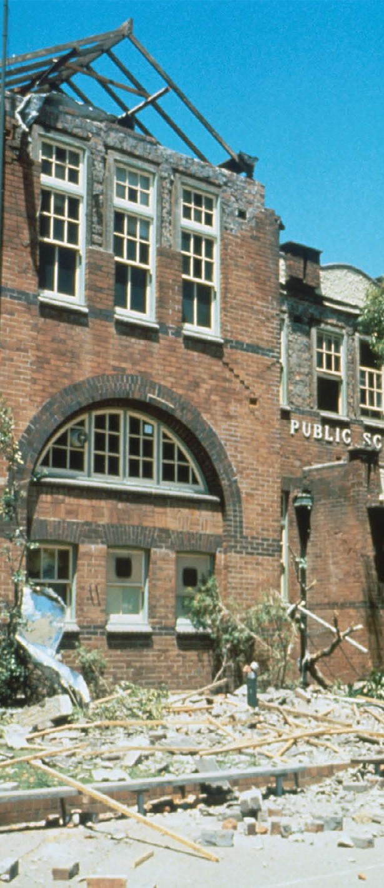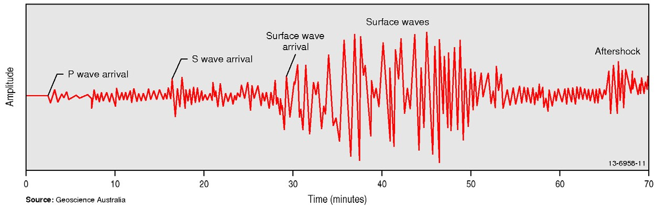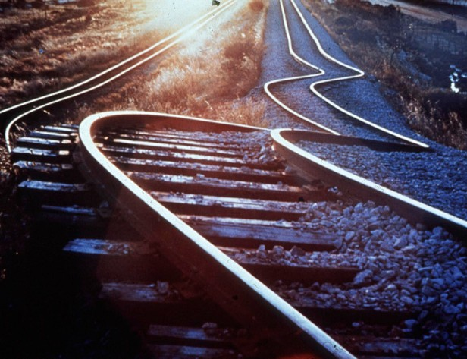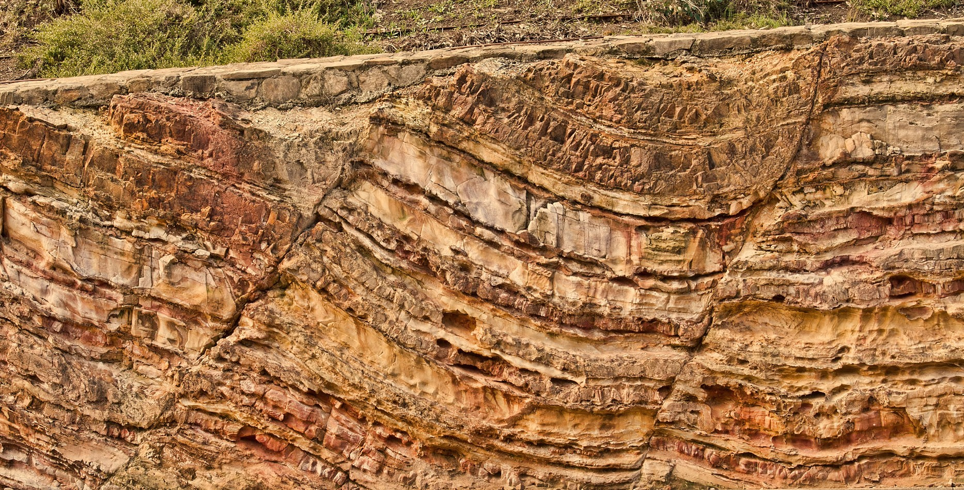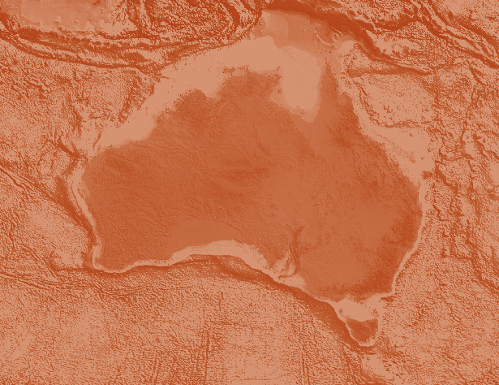

**Record** 2014/06 **| eCat** 76611

Earthquakes

Teacher notes and student activities

Gary Lewis

Editor: Clive Collins

APPLYING GEOSCIENCE TO AUSTRALIA’S MOST IMPORTANT CHALLENGES [www.ga.gov.au](http://www.ga.gov.au/)

Earthquakes

Teacher notes and student activities

GEOSCIENCE AUSTRALIA RECORD 2014/06

Gary Lewis

Editor: Clive Collins



Department of Industry, Innovation and Science

Minister for Resources and Northern Australia: Senator the Hon Matthew Canavan Assistant Minister for Industry, Innovation and Science: The Hon Craig Laundy MP Secretary: Ms Glenys Beauchamp PSM

Geoscience Australia

Chief Executive Officer: Dr Chris Pigram

This paper is published with the permission of the CEO, Geoscience Australia



© Commonwealth of Australia (Geoscience Australia) 2016

With the exception of the Commonwealth Coat of Arms and where otherwise noted, this product is provided under a Creative Commons Attribution 4.0 International Licence. (<http://creativecommons.org/licenses/by/4.0/legalcode>)

Geoscience Australia has tried to make the information in this product as accurate as possible. However, it does not guarantee that the information is totally accurate or complete. Therefore, you should not solely rely on this information when making a commercial decision.

Geoscience Australia is committed to providing web accessible content wherever possible. If you are having difficulties with accessing this document please email [clientservices@ga.gov.au.](mailto:clientservices@ga.gov.au)

ISSN 2201-702X (PDF)

ISBN 978-1-922201-95-9 (PDF)

eCat 76611

Second Edition Revised 2016 Second Edition 2014

First published 1995

Second Edition Revised Notes

This revised edition contains newly calculated magnitudes of some of Australia’s earthquakes.

In 2016, Geoscience Australia revised the magnitudes of some of Australia’s historical earthquakes as part of an international project to reassess the magnitude estimates of earthquakes around the globe. This project aimed to revise historic earthquake measurements to more accurately reflect their true size based on modernised measuring techniques.

The International Seismological Centre led this project which reassessed the location and magnitude of approximately 20 000 historical earthquakes worldwide as part of an effort to extend and improve their database of seismic events.

Acknowledgements

Original concept and content compiled by Gary Lewis (1994) Scientific advice and editing by Clive Collins and Eddie Leask Educational advice and editing by Shona Blewett and Lara Davis

Graphics, design and production by Product Development Support, Geoscience Australia

Cover images: Alice Snook and Geoscience Australia

**Bibliographic reference**: Lewis, G. & Collins, C. (ed.) 2014. *Earthquakes – Teacher notes and student activities*. 2nd ed. revised 2016. Record 2014/06. Geoscience Australia, Canberra. <http://dx.doi.org/10.11636/Record.2014.006>

Contents

What is an earthquake? 6

The causes and types of earthquakes 7

Plate tectonics 7

Interplate earthquakes 8

Intraplate earthquakes 10

Foreshocks and aftershocks 10

Volcanic activity 11

Human-induced earthquakes and other seismic events 11

How do we record earthquakes? 13

Types of seismographs 13

Analogue seismographs 13

Digital seismographs 14

Seismic waves 16

Finding the epicentre 18

Where does 8.4 come from? 19

How do we compare earthquakes? 21

Magnitude scales 21

Intensity scale 23

The effects of an earthquake 24

Large and destructive earthquakes 27

Where do earthquakes occur in Australia? 29

Significant earthquakes in Australia’s history 31

Moe (magnitude 5.4) – Eastern Victoria, 19 June 2012 31

Kalgoorlie (magnitude 5.0) – Western Australia, 20 April 2010 31

Collier Bay (magnitude 6.2) – Western Australia, 10 August 1997 32

Arnhem Land (magnitude 5.1) - Northern Territory, 30 September 1992 32

Newcastle (magnitude 5.4) – New South Wales, 28 December 1989 32

Tennant Creek (magnitudes 6.2, 6.3 and 6.6) – Northern Territory, 22 January 1988 33

Cadoux (magnitude 6.1) –Western Australia, 2 June 1979 33

Meckering (magnitude 6.5) – Western Australia, 14 October 1968 34

Adelaide (magnitude 5.4) – South Australia, 1 March 1954 35

West Tasman Sea (magnitude 5.8) - Tasmania, 14 September 1946 35

Meeberrie (magnitude 6.3) - Western Australia, 29 April 1941 35

Dalton-Gunning (magnitude 5.6) – New South Wales, 19 November 1934 35

Bundaberg (magnitude 6.0) Queensland, 7 June 1918 36

Warooka (magnitude 6.0) – South Australia, 19 September 1902 36

Beachport (magnitude 6.5) – South Australia, 10 May 1897 36

West Tasman Sea Swarm (magnitude 6.3-6.9) – Tasmania, between 1883 and 1892 36

Sydney (approximate magnitude 5) – New South Wales, 22 June 1788 36

Australia's earthquake record in the pre-instrumental era 38

Lake Edgar – Tasmania, 20 000 years ago 41

The impact of earthquakes in Australia 42

Case study: Cadell fault (NSW/Vic border) 44

Estimating the effects of an earthquake on the Cadell Fault 45

Earthquake monitoring 47

The tsunami warning system 49

Websites for further information 51

Up-to-date earthquake data from specific countries 51

Glossary 52

Student Activities 55

Answers 73

# What is an earthquake?

Earthquakes are the sudden shaking and vibrating of the Earth’s crust as a result of a rapid release of energy when rocks break and move along **faults**.

A fault is a fracture or crack in the rocks where one side has moved relative to the other (Figure 1). Faults can be just a few centimetres long or they may extend for thousands of kilometres. Earthquakes are particularly common along faults formed by plate boundaries.

The fault surface along which the rocks grind past each other may be very uneven, and friction (i.e. resistance to movement) can lock them together. The tectonic forces which are present within the Earth act upon the rocks and they become strained and deformed. This tremendous strain can build up for decades or even centuries, but eventually, the strain becomes too great and overcomes the friction. The rocks then move suddenly and ‘snap’ along the fault into a new position, producing vibrations which travel through the Earth and which may be felt at the surface as an earthquake.

Earthquakes can also be caused by the movement of magma inside a volcano, a volcanic eruption, mining activities, explosions made by humans or the impact of a meteorite.

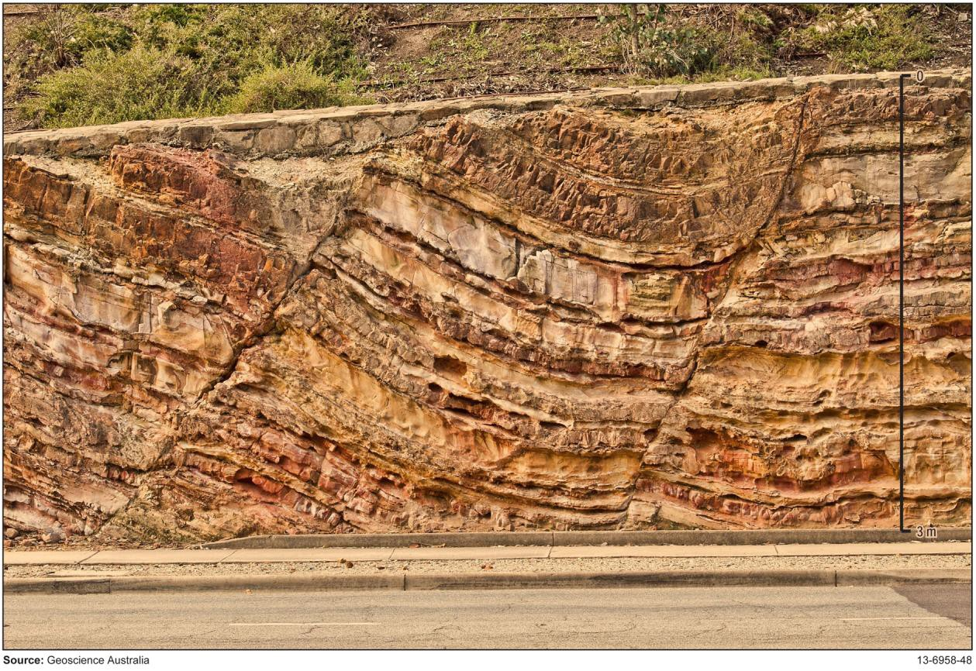

*Figure 1: Faults exposed by a road cutting in State Circle near Parliament House, Australian Capital Territory. Source: Geoscience Australia, photograph by Engin Cevik.*

# The causes and types of earthquakes

Most earthquakes are caused by the movement of the Earth’s tectonic plates. Therefore, earthquakes are most frequent along the edges of the tectonic plates where one plate is moving relative to the adjoining plate. As most of the Earth’s volcanic activity also occurs where the plates meet, many of the earthquakes are associated with volcanoes.

## Plate tectonics

The Earth's outer layer (the **lithosphere**) is made up of separate pieces called **tectonic plates**, which are on average 100 kilometres thick and are constantly moving towards, away from or past each other. Immediately below the lithosphere is a narrow zone in the mantle known as the **asthenosphere** (Figure 2). This has distinctly different properties from those in the bulk of the mantle. The lithosphere ‘floats’ and moves around on the slowly flowing asthenosphere.

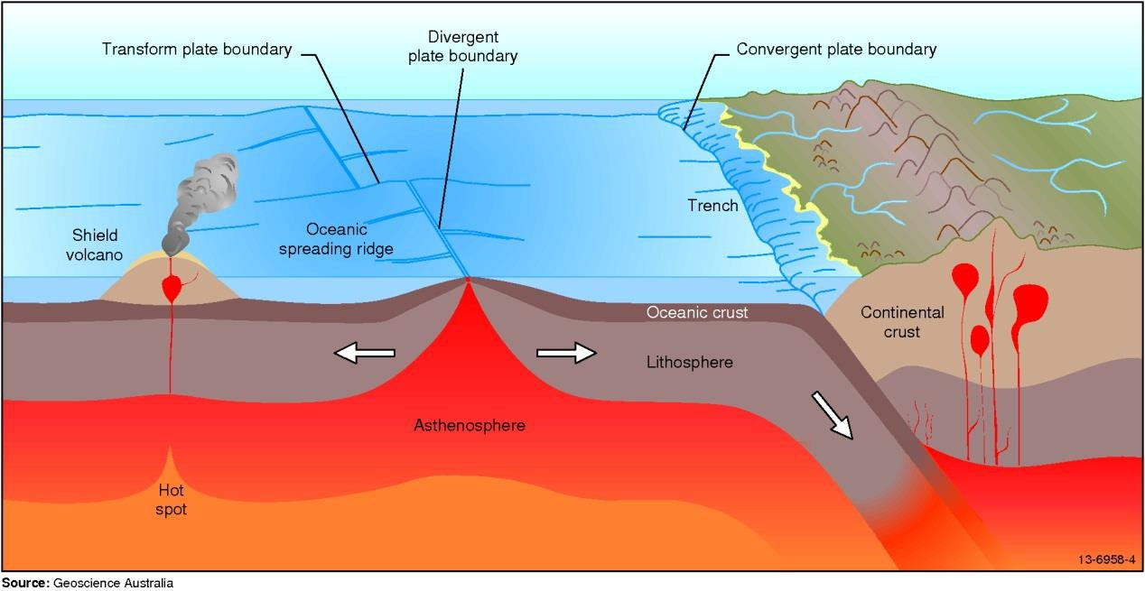

*Figure 2: Main types of tectonic plate boundaries.*

There are seven large plates and numerous smaller plates around the world. Each of these plates is moving, but not all at the same speed or in the same direction. For example, the plate containing Australia and India is moving northwards at a rate of seven centimetres a year, while the Pacific Plate is moving west at nearly nine centimetres a year. Continents are part of the plates, so they are also moving across the surface of the Earth (Figure 4).

The movement at the plate boundaries is not usually smooth and gradual, but occurs in a series of jerks because of the friction between the plates. When the stress caused by the moving plates gets too large, the rocks break and slip past each other releasing energy into the crust in the form of vibrations which we feel as earthquakes.

Some regions have more earthquakes than others. More than 80% of all recorded earthquakes take place around the edge of the Pacific Ocean, on the boundary of the Pacific Plate.

The strength of an earthquake is measured using a Magnitude Scale. An earthquake which has a magnitude of 1 is so weak it usually can’t be felt by people, while the strongest earthquake ever recorded had a magnitude of 9.5. See page 24 for more information on magnitude scales.

## Interplate earthquakes

The earthquakes which occur along tectonic plate boundaries are called **interplate earthquakes**. There are three main types of boundaries between tectonic plates (Table 1), depending on the relative

movement of adjacent plates. However, in some areas the boundary may occur over a wide zone and is not well defined.

There are also three types of faults (**Error! Reference source not found.**), classified by the direction of movement of the rocks on either side of the fault plane (i.e. the surface along which the slip occurs during an earthquake).

*Table 1: Types of plate boundaries and faults*

|  |  |
| --- | --- |
| **Plate boundary (****Figure 4****)** | **Fault type (****Figure 3****)** |
|  |  |
| **Divergent** boundary, where plates pull away from each other, allowing magma to push up from the mantle and create new crust. | Normal faults are usually associated with divergent boundaries. |
|  |  |
| **Convergen**t boundary, where one plate dives under another, destroying crust. | Faulting here is from compression, leading to  **reverse** (or **thrust**) faults. |
|  |  |
| **Transform** boundary, where plates slide horizontally past each other, neither creating nor destroying crust. | Transform boundaries are a type of **slip-strike**  fault. |

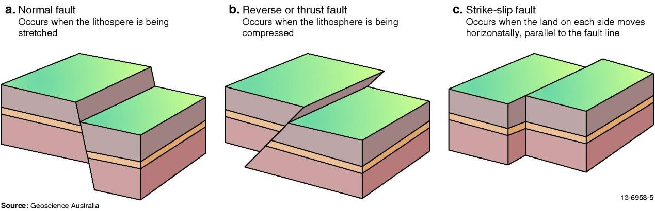

*Figure 3: The three main types of faults.*

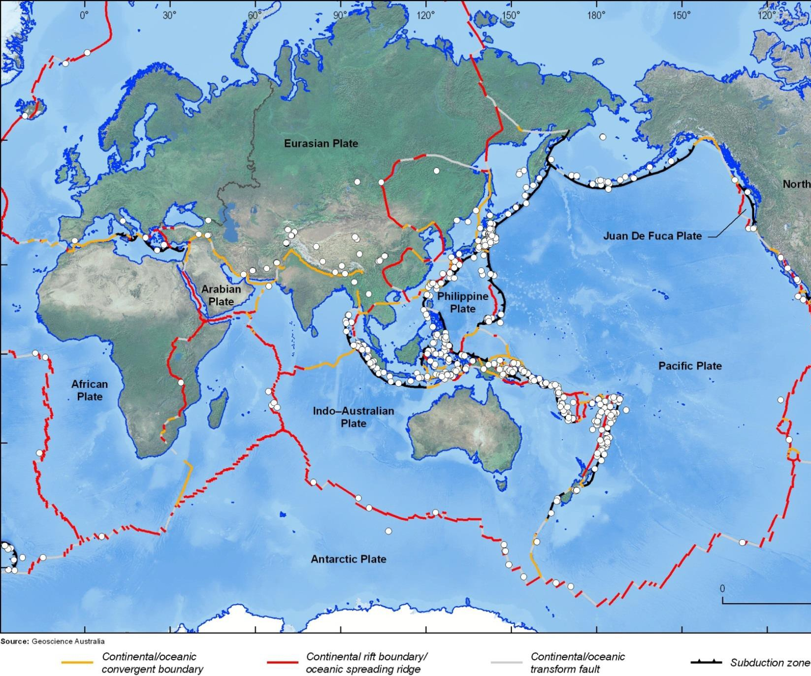

*Figure 4: Global map showing where major earthquakes occur. These coincide with tectonic plate boundaries.*

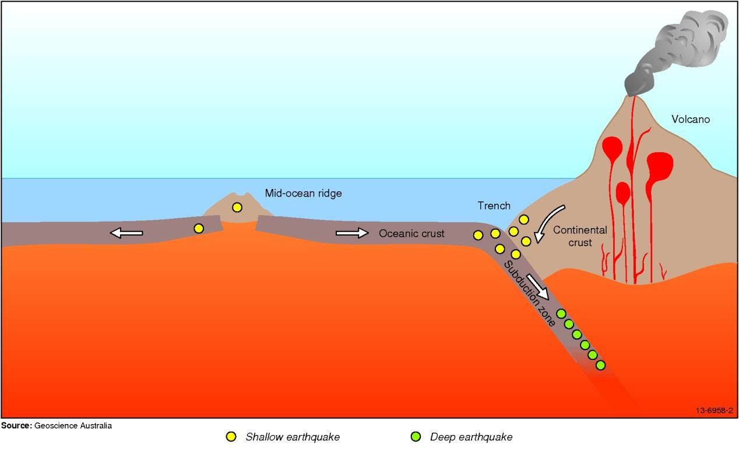

*Figure 5: Diagram of tectonic plate boundary types, showing where earthquakes occur at mid-ocean ridges and subduction zones.*

## Intraplate earthquakes

**Intraplate earthquakes** occur in the interior of plates, away from the plate margins. Intraplate earthquakes are not as common as those on plate edges (i.e. interplate earthquakes) and are usually not as large. However, major earthquakes with magnitudes of 7.0 or more do happen occasionally. All earthquakes in mainland Australia and Tasmania are intraplate, and occur relatively rarely. Most earthquakes in Australia are caused by the rocks being squeezed or compressed by horizontal forces due to the collision between the Indo-Australian plate and the Pacific Plate to the east, and the Eurasian plate to the north. This results in **reverse** or **thrust faulting** where one block of rock is pushed up over the adjacent block (see Figure 3).

## Foreshocks and aftershocks

**Foreshocks** are smaller earthquakes that may occur before a large earthquake. They are caused by fracturing of the rocks under stress. The main break along the fault causes the larger earthquake, also known as the **mainshock**. Foreshocks can start up to a year before the mainshock, as was the case before the three large earthquakes near Tennant Creek in January 1988. Not all earthquakes have foreshocks, and sometimes a series of similarly sized earthquakes, called an **earthquake swarm**, happens over months without being followed by a larger mainshock. These two phenomena limit the usefulness of foreshocks for earthquake prediction.

**Aftershocks** are smaller earthquakes that may occur after the mainshock. They are caused by the rocks in the area readjusting to the fault movement, and some may be the result of continuing movement along the same fault. The largest aftershocks are usually at least half a magnitude unit smaller than the mainshock and the aftershock sequence may continue for months or even years after

the mainshock. Not all earthquakes have aftershocks. The magnitude 5.4 Newcastle earthquake in 1989 only had one very small aftershock. Occasionally, small earthquakes with magnitudes between

* 1. and 3.5 have aftershocks. This has been observed in the Dalton-Gunning area, north of Canberra.

## Volcanic activity

Molten rock, called magma, is stored in reservoirs under volcanoes. As this magma moves upwards, it can fracture the rock through which it squeezes, causing moderate sized earthquakes. Sometimes the magma collects in a high level reservoir prior to a volcanic eruption and as it moves around it causes bursts of continuous vibration, called **volcanic tremors** (Figure 6). This type of activity can be used to predict an impending eruption.

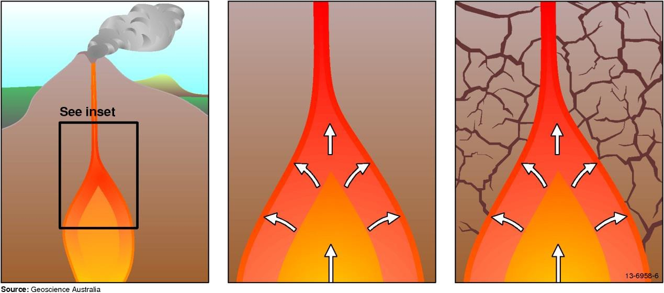

*Figure 6: Molten rock accumulates and moves upwards inside a volcano. The surrounding rock is then fractured and causes earthquakes.*

## Human-induced earthquakes and other seismic events

The explosions used to tunnel through rocks, excavate open-pit mines and break up ore cause seismic waves. Removing material during some mining processes leaves voids behind, which may unbalance existing stress in the surrounding rocks, causing small local earthquakes as the rocks settle into a new equilibrium. The magnitudes of these blasts and induced earthquakes are usually small.

Reservoir-related earthquakes can occur when a new dam is filled after construction, or when there is a major change in water level. The added weight of the water on the underlying and surrounding rocks alters the pressure in the rock, causing them to break. Also, water percolates deep into the ground, finding its way into old faults. If these are put in a stressed state they may move due to the lubricating effect of the water, leading to earthquakes.

Nuclear explosions, like mining explosions, generate seismic waves. They can be distinguished from natural earthquakes by the shape of the waves. They have been recorded with magnitudes up to 6.9.

Landslides and slow mass movement of large volumes of soil and rock may be large enough to be felt as earthquakes or as a prolonged disturbance of the ground.

Meteorites cause seismic waves to radiate from the point of impact on the Earth’s surface which may be recorded or felt at a distance like a small earthquake. Meteors which explode high in the earth’s atmosphere may produce large sound waves. These can shake the ground and appear similar to small earthquakes.

# How do we record earthquakes?

Earthquakes are detected by scientific instruments called **seismometers**. The word ‘seismo’ originates from the Greek word ‘seismos’ that means to shake or move violently and was later used to mean earthquake. Seismometers are sensors that detect and convert any small movement in the earth into an electrical signal.

These movements may be caused by seismic waves from natural events such as earthquakes, as well as man-made disturbances such as traffic noise and mining activity. The digital signal produced by the seismometer is then sent to a computer for analysis. The resultant data, when graphed, is called a **seismogram** (Figure 7). The whole system used to record earthquakes is called a **seismograph**. Seismometers are usually placed on solid **bedrock**, preferably far from urban areas, mining, and other installations (e.g. railway lines) that may cause vibrations in the Earth which could mask the shaking due to small earthquakes.

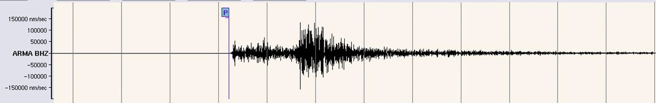

*Figure 7: Seismogram recorded by a seismometer in Tamworth, NSW. Source: Geoscience Australia*

## Types of seismographs

### Analogue seismographs

Older, analogue systems consisted of a seismometer (i.e. sensor) connected to a recording unit, which was usually a drum and stylus (Figure 8). When the Earth shakes, the weight tends to remain stationary while the spring stretches and compresses in response to the shaking. The relative movement between the Earth and the stationary weight is recorded by a pen which draws a trace on paper mounted on a rotating drum.

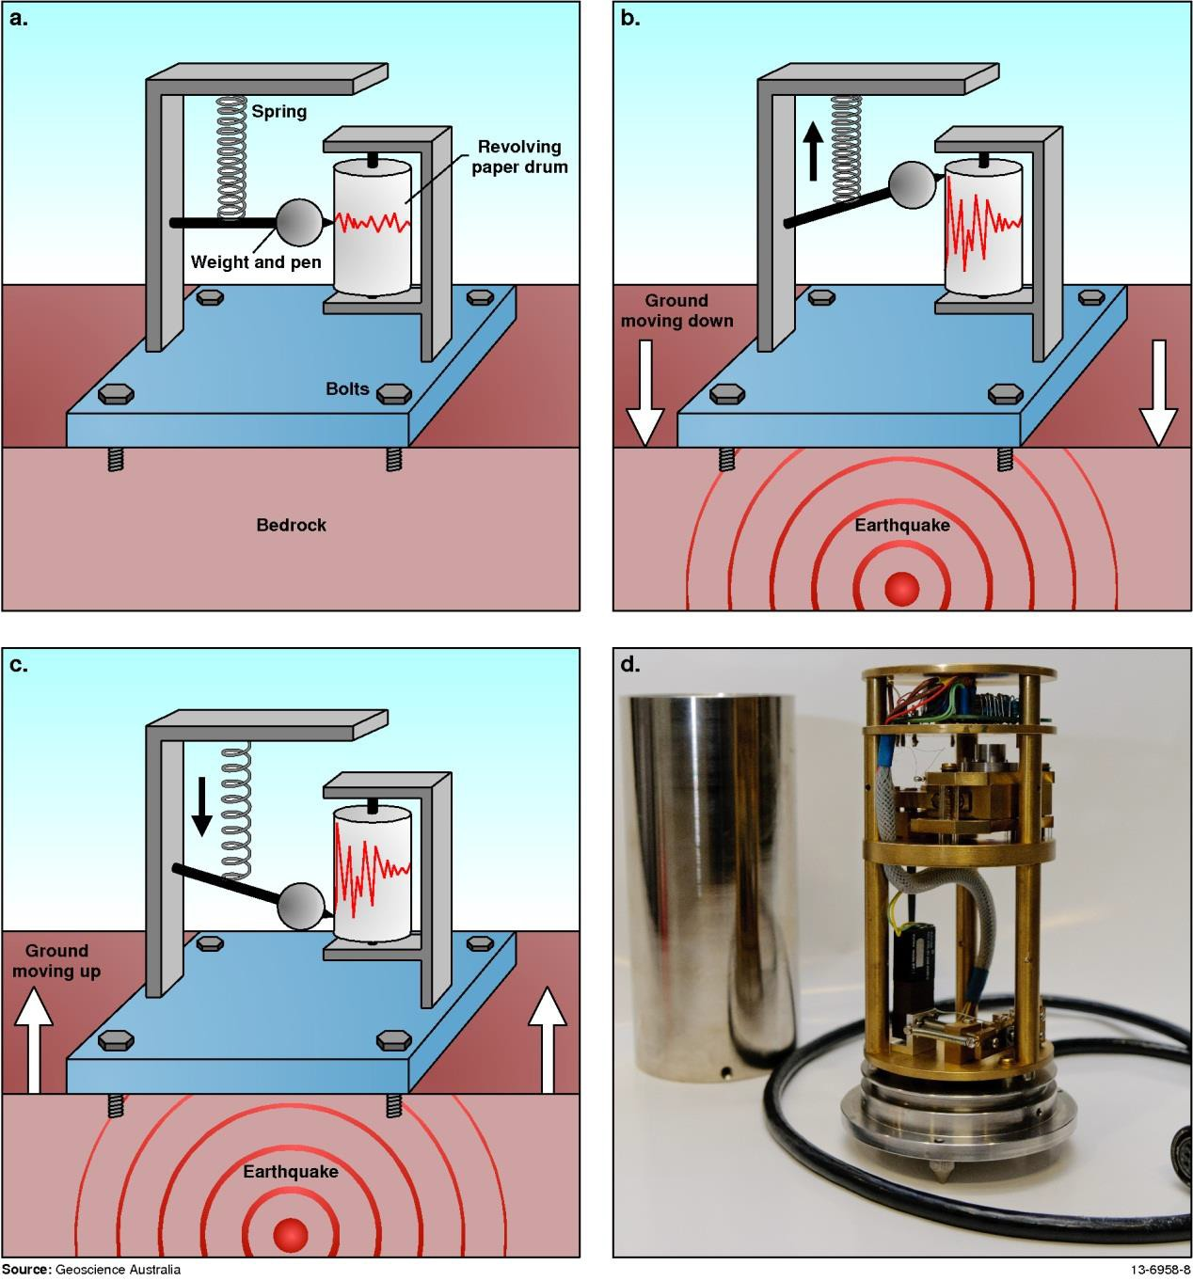

*Figure 8: An analogue seismograph, consisting of a seismometer (spring and weight) and a revolving paper drum recorder. Figure 8d is a simple seismometer with the weight and spring mounted in the second section. Photo credit: Hashim Carey.*

### Digital seismographs

Modern seismographs convert the electrical signals from the seismometer (i.e. a sensor) into digital signals which can be fed straight into a computer and recorded without any need for a paper drum and stylus. Many seismometers now detect earthquakes through an electronic feedback circuit (**Error! Reference source not found.**). As the earth moves, the mass is held steady by the electronics. The amount of force required to achieve this corresponds to a voltage. Calculations can be performed on this data which tell us the acceleration of the ground during the earthquake. The movement of the ground is usually measured in three dimensions: up-down, north-south and east-west.

Digital stations record about 20 samples each second. Over the course of a day, this may add up to about five megabytes (5 MB) of data in 24 hours. Stations may also record high-sample rates of 200

samples per second for in-depth analysis and research. Data is constantly transmitted through a network of stations to a data centre to guarantee rapid monitoring of earthquake activity.

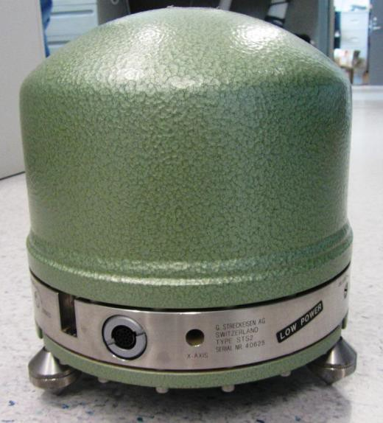Did you know?

Smartphones and some laptops contain accelerometers. They are useful for changing the display from landscape to portrait when you tip the screen on its side.

The Quake Catcher Network [(http://qcn.standford.edu/)](http://qcn.standford.edu/)) allows members of the public to help in the detection of seismic activity by using the accelerometers in their laptops, or simple, external motion sensors.

*Figure 9: A modern seismometer, hermetically sealed against all weather.*

There are seismometers that each record different strengths and types of seismic waves. Modern

instruments are sensitive enough to register even the smallest ground movements of only a few nanometres. Seismometers have also been developed for detecting very strong signals so they can be placed close to active tectonic zones where large earthquakes are expected to occur. These are known as **accelerometers**. Accelerometers are used widely in Indonesia and Japan.

Why measure acceleration?

Acceleration is quantified as metres per second per second (m/s/s, or m/s2). From this, we can calculate the velocity, metres per second (m/s), because acceleration is the change in velocity per time interval. Using the velocity we can calculate the displacement (the distance that the ground has moved from its starting position).

𝑣=

𝑑�

𝑎=

𝑑�

𝑑�

𝑑�

=

𝑑2�

𝑑�2

where

s = displacement (m) v = velocity (m/s)

a = acceleration (m/s2)

t = time (s)

Seismograms not only tell us that an earthquake has happened but they can also tell us where it occurred, how big it was, in which direction the rocks broke along the fault line and what tectonic forces are active in the area where it occurred. Information contained in seismograms can also tell us about the internal structure of the Earth, such as what material the core is made of.

Activity Idea

Make a very simple seismometer by using some common items.

You will need: a cardboard box, a hole-punch, sticky tape, plasticine or blu tac, a felt-tip pen, string, and piece of card.

* + 1. Turn the box on its side so that an open side is facing you.
    2. Using the hole-punch, make a hole in the roof of the box. Use tape to strengthen the corners of the box.
    3. Squash a large piece of plasticine or blu tac onto the felt-tip pen near the nib.
    4. Tie an end of the string to the top of the pen.
    5. Thread the other end through the hole in the roof of the box. Now stand the box so that the pen hangs free.
    6. Attach the free end of the string to the top of the box with the sticky tape, making sure the pen is only just touching the floor of the box.
    7. Now put the piece of card under the nib of the pen, and your seismometer is ready to go!

## Seismic waves

An earthquake releases energy that travels away from the earthquake in all directions in the form of waves called **seismic waves**. There are three main types of seismic waves: **P** (**primary** or **compressional**) waves, **S** (**secondary** or **shear**) waves and **surface** waves. P and S waves travel through the rocks, while surface waves travel along the surface of the earth.

P waves force the rocks to move back and forth along the direction in which the waves are travelling (Figure 10). These are also known as longitudinal waves or pressure waves. P waves can travel through both solids and liquids, which means they can travel through the crust, the mantle and the core. This type of wave travels at the speed of sound in the material it is passing through. P waves travel at around 6 km/s in hard rocks near the surface and at over 13 km/s in the lower mantle.

P waves take less than 20 minutes to reach the other side of the earth, a distance of almost 13 000

kilometres.

In S waves, the rocks move at 90 degrees to the direction in which the wave is travelling (Figure 10). This could mean up and down, or side to side. S waves can only travel through solids. This means they do not move through the outer core of the earth which is composed of liquid iron and nickel.

S waves travel at around 3 km/s in hard rocks near the surface.

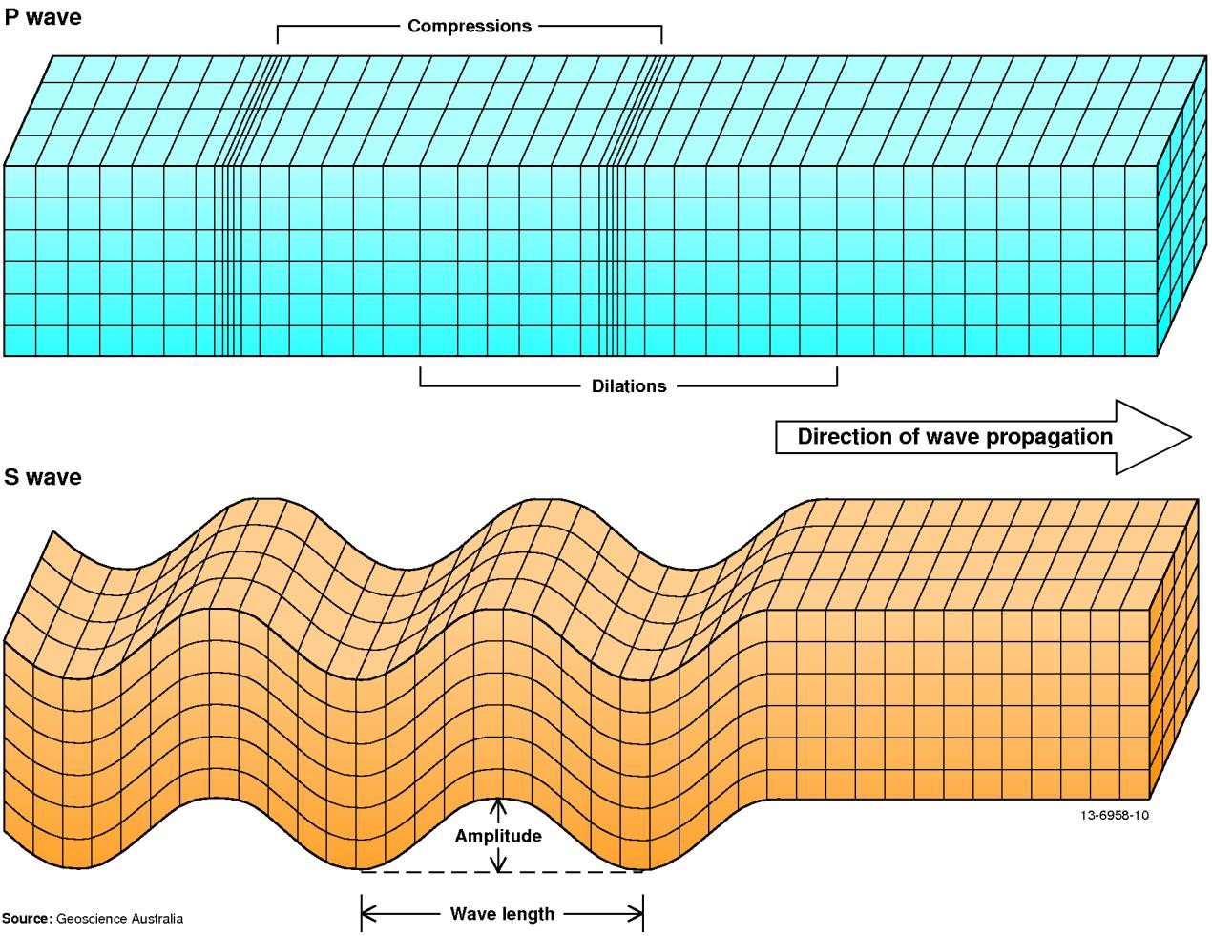

*Figure 10: P (compressional) waves and S (shear) waves.*

Why do S-waves not travel through liquid?

Simply put, fluids don’t support shear stresses which are required for S, or transverse, waves.

Imagine a skipping rope lying on the ground. Each end is being held by a person so that the rope is taut. One person flicks the end of a skipping rope sideways. The rope returns back to its original position. The energy put into the rope to move it has been converted by the rope to restore it to its original shape.

Now imagine a bathtub full of water. At one end of the tub put your hand in the water and flick your hand sideways, pushing the water. Liquid has no intrinsic shape, and so doesn’t return to its original shape as it sloshes about in the bath. In other words, the energy from your hand movement has been spread through all of the water, rather than being used to restore the water to its original shape.

## Finding the epicentre

The location of an earthquake’s origin under the surface is known as the focus. The earthquake’s

**epicentre** is the point on the Earth’s surface directly above the focus (Figure 12).

Of all the seismic waves, P waves travel fastest and arrive at a seismometer first, hence the name ‘primary’. S waves arrive next, followed by surface waves. A typical seismogram of an earthquake shows these arrivals (or phases) recorded in that order.

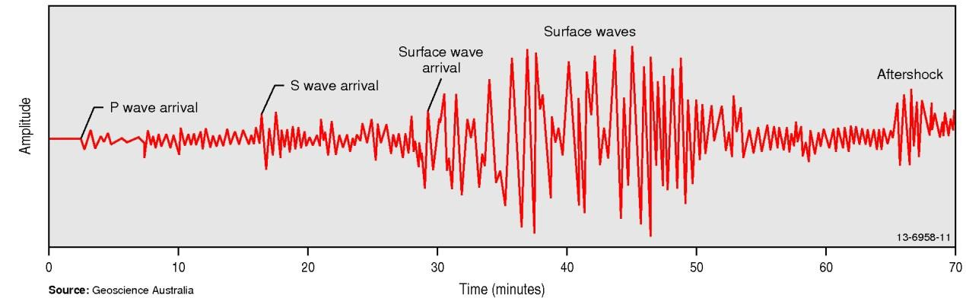

*Figure 11: Seismogram of a typical local earthquake, showing different arrival times for P and S waves, surface waves and an aftershock.*

However, a seismogram from a single seismic recording station is insufficient to calculate the location of an earthquake. Data from at least three stations is necessary. The P waves arrive before the

S waves and the time difference between the two waves gives an indication of how far the seismometer is from the epicentre (the geographical point on the surface above the slipping rocks).

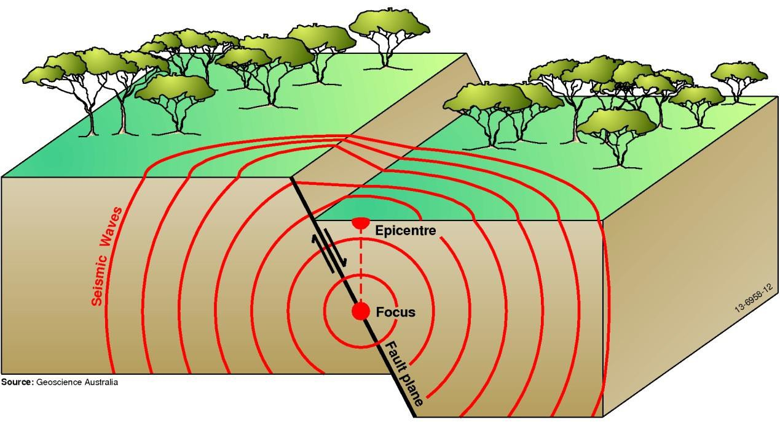

*Figure 12: An earthquake caused by the displacement of the Earth’s crust along a fault plane. The displacement starts at the focus below the surface; the epicentre is directly above the focus. Energy generated by the earthquake travels away from the focus in all directions as seismic waves.*

The basic process required in the calculation of the location of an earthquake epicentre involves three main steps.

1. Calculate the time interval (in seconds) between P and S waves using data from at least three different seismograms.
2. Convert the time difference into a distance between the recording station and the epicentre (in kilometres). One technique is to multiply this number by 8.4 (see below ). Alternatively, read off a time-distance graph (see activity “Epicentre Hunt”). Do this for each of the three seismograms.
3. On a map, draw circles of radius ‘d’ from each of the seismic stations. The spot where the three circles intersect (cross-over) is the epicentre of the earthquake (Figure 13).

### Where does 8.4 come from?

The P wave travels faster than the S wave. Therefore the P wave arrives at the seismograph earlier than the S wave, and the difference between these arrival times is called the 'S-P time'. The further the earthquake is from the seismograph, the larger the S-P time. If the P wave travels at 6 km/s and the S wave travels at 3.5 km/s then the S-P time will increase by 1 second for every 8.4 km increase in distance. Therefore, multiplying the S-P time by 8.4 gives the distance between the earthquake and the seismograph.

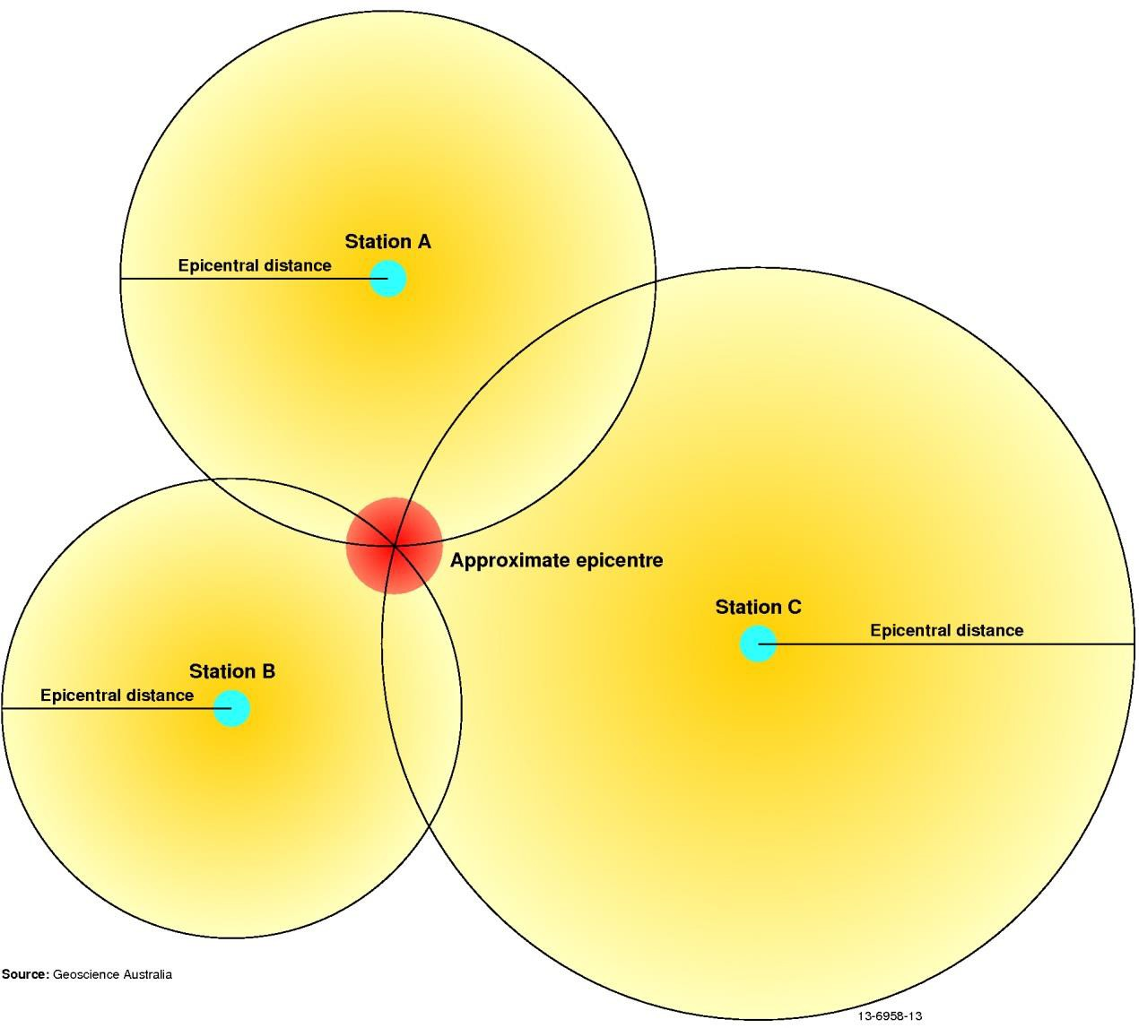

*Figure 13: The epicentre of an earthquake is calculated using a minimum of three seismic stations. Where the three circles overlap is considered to be a reliable approximation of the epicentre.*

**Activities: Find Detritus; Epicentre Hunt.**

# How do we compare earthquakes?

There are two properties of an earthquake which can be quantified.

The **energy** released is described by its magnitude, and is calculated using mathematical formulae. This number is constant for a chosen earthquake, regardless of where the measurement was taken.

The **effects** of an earthquake are described using an intensity scale, using observations made by people who have experienced the earthquake or by observed structural damage to buildings. This number is dependent on the size and depth of the earthquake, the distance from the quake and the local terrain.

## Magnitude scales

There are several types of magnitude scales, but the two most commonly used are the **Richter scale** and the **moment magnitude scale (MMS)**. To calculate the magnitude using these scales you must know the *size* (**amplitude**) of the seismic waves recorded on a seismogram, and the *distance* between the seismometer and the earthquake. This information is put into a formula to calculate the magnitude.

The Richter scale has traditionally been used to measure earthquake magnitudes. However, it is not an accurate measure once earthquakes are larger than about 6.5 in magnitude.

The moment magnitude scale has become the universally accepted method of calculating the size of an earthquake. It is based on the physical properties of the fault which caused the earthquake. These properties are the *rigidity* of the crust where the earthquake occurred, the *average displacement* of the fault, and the rupture’s *dimensions* (length, width and therefore area).

The magnitude scale is logarithmic, so for every unit increase in magnitude there is a 10-fold increase in the size of the waves in the seismogram, and a 30-fold increase in the energy released. For instance, a magnitude 6.0 earthquake releases approximately 30 times more energy than a magnitude

* 1. Fortunately, smaller earthquakes occur much more frequently than large ones and most cause little or no damage (Figure 14).

In 2016, Geoscience Australia revised the magnitudes of some of Australia’s historical earthquakes as part of an international project to reassess the magnitude estimates of earthquakes around the globe. This project aimed to revise historic earthquake measurements to more accurately reflect their true size based on modernised measuring techniques.

As custodians of Australia’s earthquake data, Geoscience Australia has updated information related to Australia’s historical earthquakes, resulting in significant changes to what wre previously thought to be some of Australia’s largest events ever recorded.

The International Seismological Centre led this project which reassessed the location and magnitude of approximately 20 000 historical earthquakes worldwide as part of an effort to extend and improve their database of seismic events.

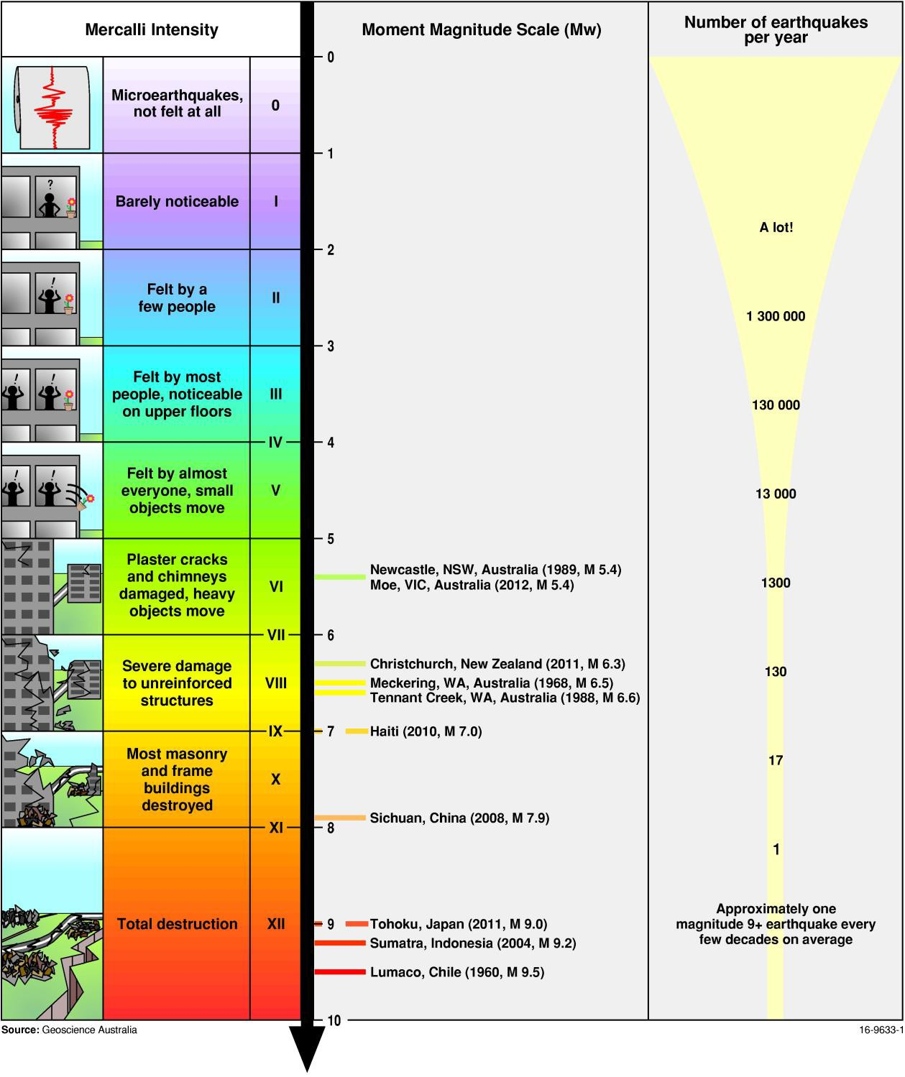

*Figure 14: The two scales compared side by side, a short list of recent earthquakes and the average number of earthquakes of each magnitude that occur per year.*

## Intensity scale

The severity of the shaking caused by an earthquake depends on:

* + - the distance of the observer from the epicentre,
    - the depth of the earthquake focus, and
    - the local **topography** and ground conditions.

The Modified Mercalli (MM) intensity scale takes all of these into account, rating the *effect* of an earthquake (Figure 14), rather than just the energy released. This scale, which ranges from I (barely noticeable) to XII (total destruction), is a measure of observed ground shaking and any damage the earthquake caused.

An earthquake can be felt at different levels of intensity depending on how far away the observer is and the type of ground a person is standing on. For example, the intensity would be greater on soft sediment than on solid rock. The intensity may also be higher on hilltops.

**Activity: Quakeville Earthquake**

# The effects of an earthquake

Magnitude, that is, the energy released by an earthquake, is not the sole factor in determining how much damage will be caused. The proximity to man-made structures/buildings, the type of buildings, the soil type, and the timing and nature of warnings to residents can affect the extent of injuries or harm.

The need to consider more than just magnitude when analysing the effects of an earthquake is evident when comparing the Meckering and Newcastle earthquakes (Table 2)

*Table 2: Comparison of Newcastle and Meckering earthquakes.*

|  |  |  |  |  |  |
| --- | --- | --- | --- | --- | --- |
| **Location** | **Year** | **Magnitude** | **Injuries** | **Fatalities** | **Damage costs** |
|  |  |  |  |  |  |
| Newcastle, NSW | 1989 | 5.4 | 160 | 13 | $4 billion |
|  |  |  |  |  |  |
| Meckering, WA | 1968 | 6.5 | 20 | 0 | $5 million |

The Meckering earthquake in WA (Figure 15) generated a wall of soil and rock up to two metres high along a fault line almost 40 km long, and yet there was no loss of life (Table 2). This fortuitous outcome was thanks to it being a public holiday and the fact that the population of Meckering at the time was only 240.

By comparison, Newcastle is a highly populated city, and falling buildings were the main factor in the fatalities. Thirty-five thousand homes and 147 schools were damaged, and yet the earthquake was smaller than Meckering.

Even magnitude 4.0 earthquakes that occur near built-up areas can occasionally topple chimneys or result in other damage which could potentially cause injuries or fatalities.

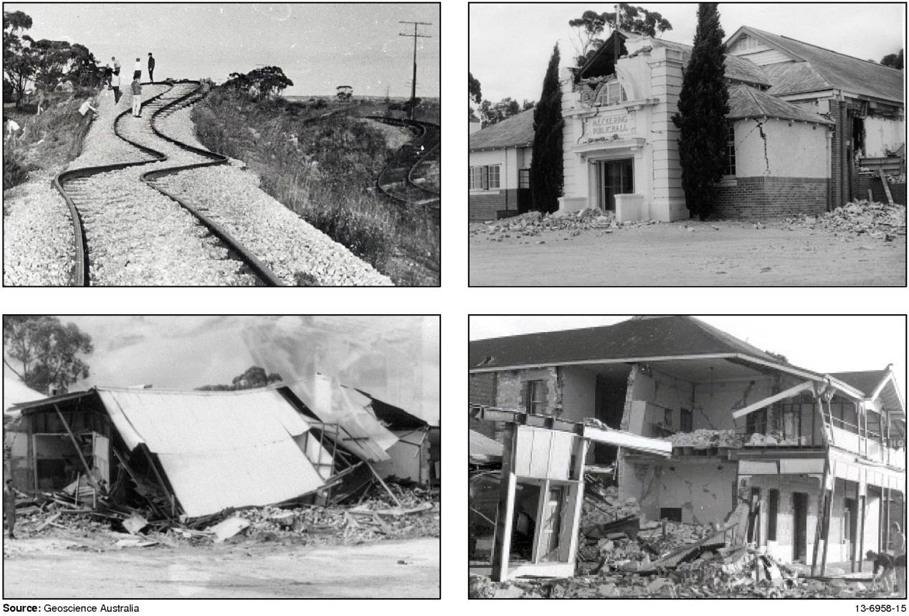

*Figure 15: Damage caused by the 1968 magnitude 6.5 Meckering earthquake, 130 km east of Perth, Western Australia. Source: Alice Snooke; WA Newspapers; Ian Everingham, Peter Gregson, the West Australian newspaper, Alice Snooke, Wayne and Brendan Peck*

Earthquakes of magnitude 4.0 or greater may also trigger landslides, which can cause casualties (Figure 16a). Landslides are a serious consequence of earthquakes in mountainous regions, such as Papua New Guinea.

In areas underlain by water-saturated sediments, large earthquakes, usually magnitude 6.0 or greater, may cause **liquefaction** (Figure 16b). This is a process where the shaking causes the wet sediment to behave like quicksand and flow. Subsidence from this may cause buildings to topple or sink into the ground, and the sediment may erupt at the surface causing craters and fountains.

Earthquakes under the sea or close to the shore can disturb the seabed and cause waves in the ocean called **tsunami** (Figure 16c). Very large earthquakes in the sea off Indonesia in 2004 and off Japan in 2011 caused tsunami, which crossed the Indian and Pacific oceans and caused extensive

damage and loss of life in coastal regions.1

The destruction due to strong earthquake shaking can be made worse by fires caused by downed power lines and ruptured gas mains (Figure 16d).

 **Activity: Earthquake hazard map**

1 For more information on tsunami, please visit our education website [(www.ga.gov.au/education)](http://www.ga.gov.au/education).

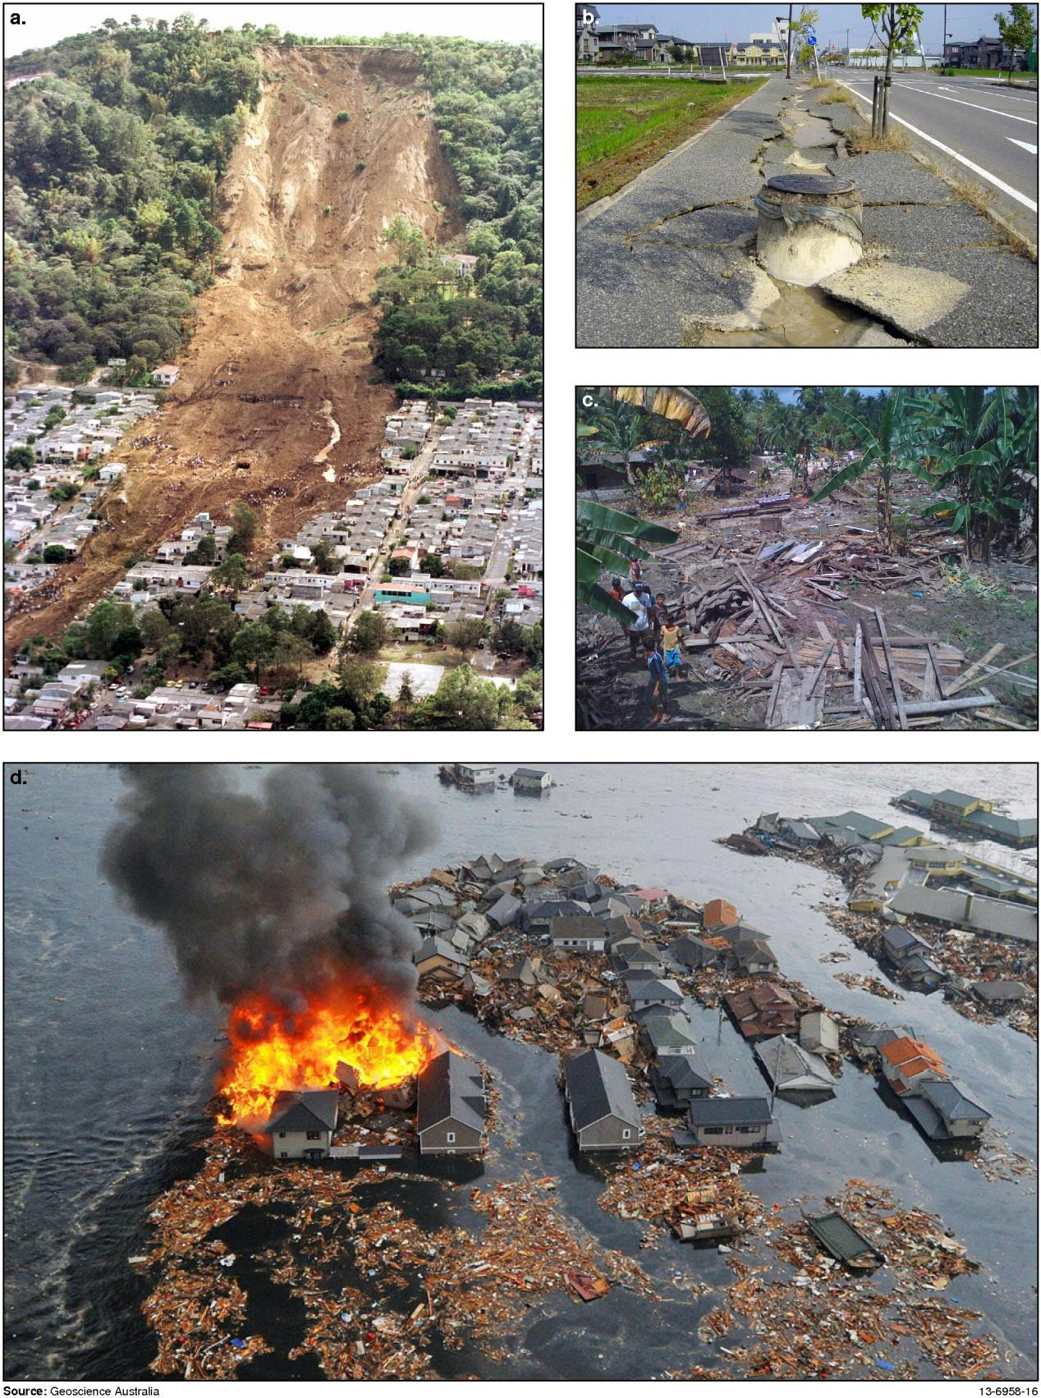

*Figure 16: a) A landslide caused by the 2001 El Salvador quake, b) Soil liquefaction took place on the road in Japan after the Chuetsu Earthquake in 2004 causing large cracks to form, c) Masokut village, on the Mentawai island of Sipora. They had 73 houses before the 2010 earthquake/tsunami – now they have one, d) A fire ignites in a home that has been damaged and nearly submerged by the 2011 tsunami and earthquake in Natori City, Japan.*

*Source: a) USGS Landslides Hazards Program:* [*<h*](http://landslides.usgs.gov/learning/images/foreign/ElSalvadorslide.jpg)*t*[*tp://landslides.usgs.gov/learning/images/foreign/ElSalvadorslide.jpg*](http://landslides.usgs.gov/learning/images/foreign/ElSalvadorslide.jpg)*>, b) Wikimedia Commons, photograph by Tubbi 2005, c) AusAid Photolibrary, photograph by Lambhot/SurfAid, 1 November 2010,*

*d) AP Photo/Kyodo News*

# Large and destructive earthquakes

Earthquakes occur all over the planet, but some areas are more prone than others to large magnitude events because of their proximity to fast-moving plate boundaries. Areas near subducting plate boundaries have the greatest potential and highest risk for large earthquakes. These areas include the subduction zones around the Pacific Ocean, from New Zealand to Tonga, Vanuatu to Papua New Guinea, the Philippines past Japan to eastern Russian, and Alaska; Mexico through to southern Chile. Also at great risk is the Sunda Arc subduction zone south of Indonesia, in the Indian Ocean.

*Table 3: Top five largest earthquakes worldwide since 1900.*

**Region Mag Fatalities Date - Time**

**Description**

1. Valdivia, Chile 9.5 1655 22 May

**1960**

19:11

Caused Pacific-wide tsunami with damage and deaths in Chile, Hawaii, Japan, Philippines and west coast of the United States. 1655 dead, 3000 injured, 2 million homeless and over $650 million in damages. Severe shaking damage in Chile, tsunami waves up to 11.5 metres, preceded by strong foreshocks of magnitude 7.0+, many aftershocks and two days later the volcano Puyehue erupted, lasting several weeks.

1. Prince William Sound, Alaska

9.2 125 28 Mar

**1964**

03:36

Heavy damage ($311 million) to local town buildings and uplift of the ground up to 11.5 metres. A large tsunami, recorded at 67 metres high at Valdez Inlet, devastated Alaska and reached Hawaii.

1. Off the west coast of northern Sumatra, Indonesia

9.1 227 898 26 Dec

**2004**

00:58

227 898 people dead or missing, 1.7 million people displaced in 14 countries by earthquake and resulting tsunami, affecting South Asia and East Africa. The most casualties for any tsunami in recorded history. Led to the set-up of Tsunami Warning Centres in the Indian Ocean.

1. Kamchatka, Russia

9.0 Unknown 4 Nov

**1952**

16:58

Severe and locally damaging tsunami generated with local wave heights of 13 metres, reached Hawaii, Alaska, California, Peru and Chile. No recorded casualties.

1. Near the east coast of Honshu, Japan

9.0 28 050 11 Mar

**2011**

05:46:23

Over 20 000 dead or missing, over 300 000 buildings destroyed in Japan by earthquake and resulting Pacific-wide tsunami. Maximum run-up height of 37.88 metres in Miyako. Geological effects in Japan included landslides, liquefaction, horizontal displacement and vertical subsidence. Economic loss in Japan estimated at 309 billion US dollars. Tsunami reached the west coast of North and South America, Northern Indonesia, Hawaii and even broke off ice slabs from Antarctic ice shelfs.

*Adapted from source: Magnitude 8 and Greater Earthquakes Since 1990 – Earthquake Hazards Program*

[*http://earthquake.usgs.gov/earthquakes/eqarchives/year/mag8/magnitude8_1900_date.php*](http://earthquake.usgs.gov/earthquakes/eqarchives/year/mag8/magnitude8_1900_date.php)

**Note:** Large earthquakes can cause vast amounts of damage. However, if they occur in remote areas, such as Alaska, away from population centres, the loss of lives is limited. Damage and loss of life can also be reduced by implementing strict standards for building construction in earthquake prone areas and installing tsunami early-warning systems.

*Table 4: Top five most destructive earthquakes in recorded history.*

**Date Location Deaths Mag. Description**

**1** 23 Jan

**1556**

Shaanxi (Shensi), China

830 000 Estimated: 8 Large scale destruction of city walls, temples, offices

and houses were reported. Geological effects reported with this earthquake included ground fissures, uplift,

subsidence, sand-blows, liquefaction and landslides. It

was estimated that the identified death toll was 830 000, with many more unidentified deaths.

1. 12 Jan

**2010**

Haiti region 316 000 7.0 Official estimates are 316 000 people dead, 300 000

injured, 1.3 million displaced, 97 294 houses destroyed and 188 383 houses damaged in the Port-au-Prince

area and southern Haiti.

1. 27 July

**1976**

Tangshan, China

242 769 7.5 Official fatality figure is 242 769, other estimates

suggest 655 000 deaths, 799 000 injured and widespread damage in Tangshan and as far as Beijing.

**4** 11 Oct

**1138**

Aleppo, Syria

230 000 Unknown Aleppo’s citadel collapsed, the city walls crumbled and

rocks cascaded into the streets. Several smaller towns and manned forts were reduced to rubble.

**5** 26 Dec

**2004**

Sumatra 227 898 9.1 227 898 people dead or missing, 1.7 million people

displaced in 14 countries by earthquake and resulting tsunami, affecting South Asia and East Africa. Most

casualties for any tsunami in recorded history.

*Adapted from source: Earthquakes with 50 000 or More Deaths – Earthquake Hazards Program*

*<*[*http://earthquake.usgs.gov/earthquakes/world/most_destructive.php*](http://earthquake.usgs.gov/earthquakes/world/most_destructive.php)*>*

**Note:** Many earthquakes in history happened before modern measuring techniques. Their magnitudes are calculated using historical and geological records.

Earthquakes larger than magnitude 8 occur on average once a year. Damage caused by these events can vary as a function of:

* local population density,
* local geological conditions,
* the quality of local building practices,
* history of earthquakes in the region; and
* their effect on cultural responses to earthquakes.

# Where do earthquakes occur in Australia?

Earthquakes in Australia occur as a result of forces acting on the boundaries of the Indo-Australian plate.

Shallow intraplate earthquakes occur in the relatively stable interior of continents away from plate boundaries. Although Australia is not on the edge of a plate, it still experiences earthquakes because the Indo-Australian plate is colliding with the Eurasian, Philippine and Pacific plates as it moves north. This causes a build-up of compressive stress in the interior of the Indo-Australian plate, which is released during earthquakes.

There are, on average, 80 earthquakes of magnitude 3.0 or more in Australia each year. Earthquakes above magnitude 5.5 occur on average every two years. About every five years, there is a potentially disastrous earthquake of magnitude 6.0 or more (Figure 17). Adelaide has experienced more medium- sized earthquakes in the past 50 years than any capital city. This is because South Australia is slowly being squeezed in an east-west direction by about 0.1 millimetres per year. Although earthquakes cannot be predicted accurately, measuring these changes and combining that information with Adelaide's earthquake history helps scientists to develop an understanding of when the next big earthquake might happen.

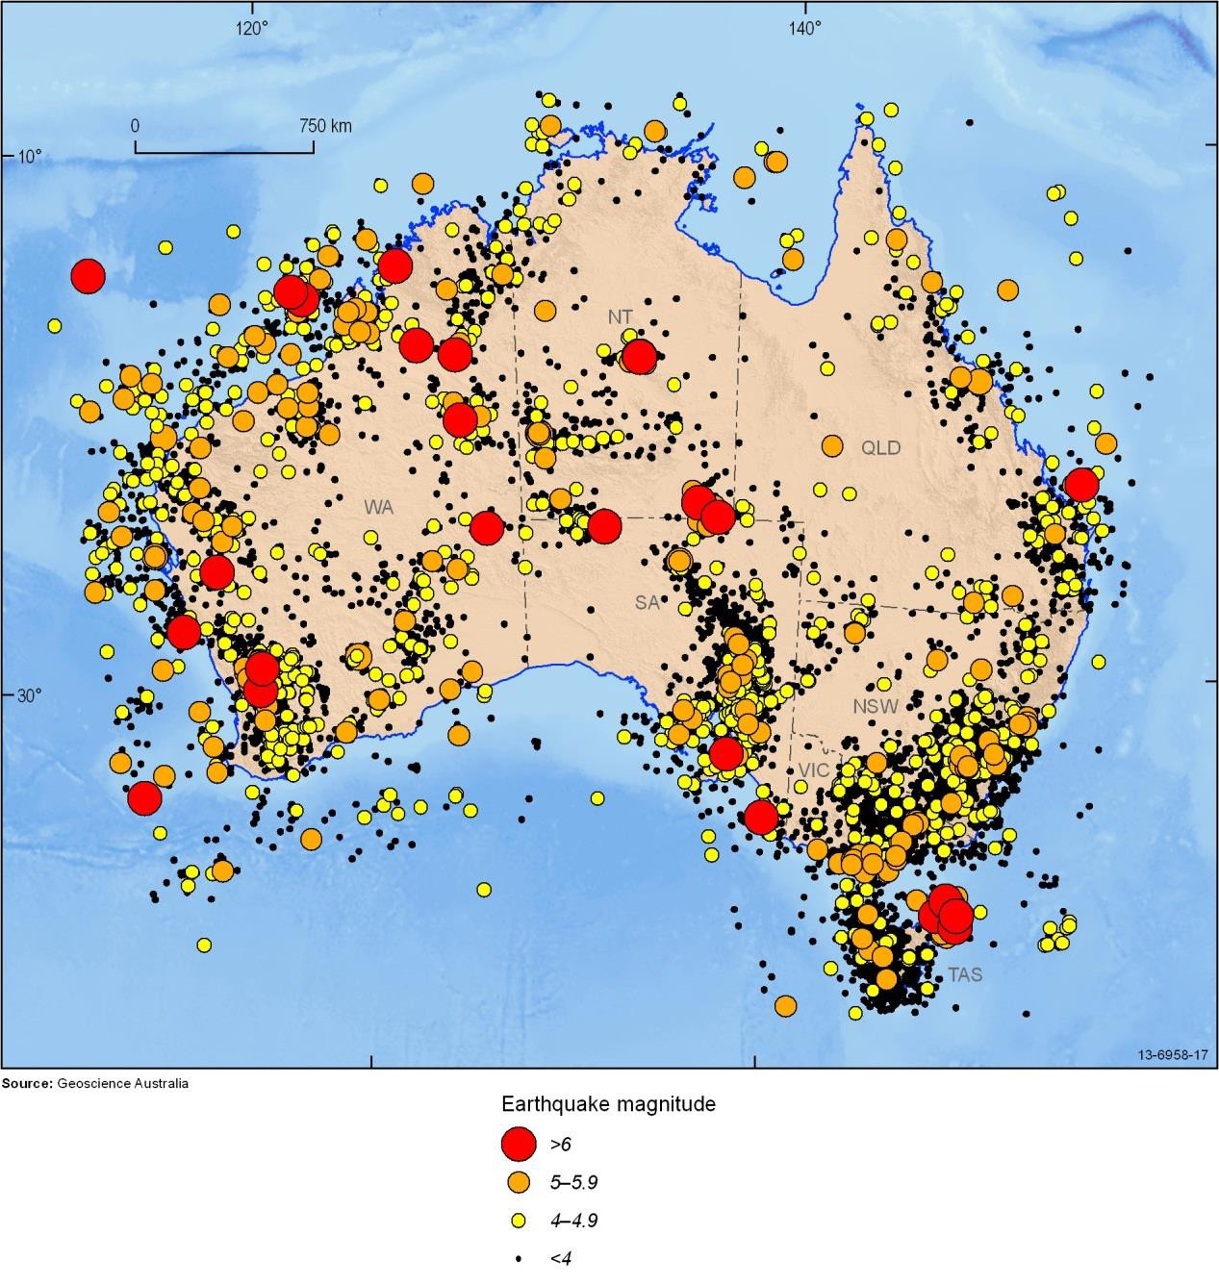

*Figure 17: All detected Australian earthquakes up until 2011.*

Significant earthquakes in Australia’s history2

Australia's largest instrumentally recorded earthquake happened in 1988 at Tennant Creek in the Northern Territory with an estimated magnitude of 6.6. Earthquakes of magnitude 4.0 or more are relatively common in Western Australia with one occurring approximately every five years in the Meckering region. Historically a number of significant earthquakes have been recorded across Australia.

## Moe (magnitude 5.4) – Eastern Victoria, 19 June 2012

A magnitude 5.4 earthquake occurred on 19 June 2012 at 8:53pm local time, 10km southwest of Moe and 130km southeast of Melbourne. The earthquake was felt across Victoria, with reports of it being felt from as far away as Deniliquin in NSW, around 330km from the epicentre. There were over 300 aftershocks recorded, the largest of which was a magnitude 4.4 recorded on the 20th of July 2012. The Moe earthquake was the largest earthquake recorded in Victoria since the magnitude 5.7 Mt Hotham earthquake in May 1966. From 2009 there has been an exceptionally high occurrence of seismicity related to significant earthquakes recorded in Gippsland, Victoria.

## Kalgoorlie (magnitude 5.0) – Western Australia, 20 April 2010

A magnitude 5.0 earthquake occurred under Kalgoorlie-Boulder at a depth of approximately 1.7 kilometres on 20 April 2010. Damage occurred to a number of buildings and over 250 aftershocks were recorded (Figure 18).

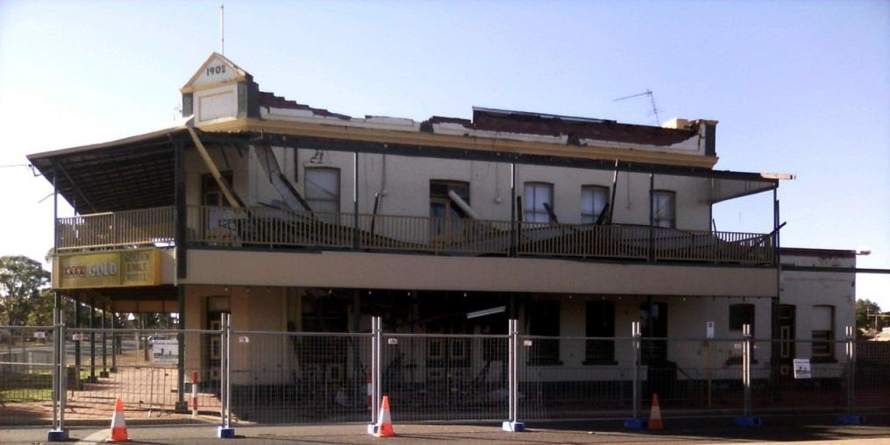

*Figure 18: The Golden Eagle Hotel’s roof which caved in after Kalgoorlie earthquake.*

1. See more examples on the Geoscience Australia website.

## Collier Bay (magnitude 6.2) – Western Australia, 10 August 1997

A magnitude 6.2 earthquake occurred on August 10 1997 in Collier Bay, Western Australia. The epicentre was about 50 kilometres offshore from Koolan Island. It was widely felt from Broome to Kununurra and on several boats in the area. Concrete building foundations at Cockatoo Island were damaged and strong shaking was experienced at Cape Leveque.

## Arnhem Land (magnitude 5.1) - Northern Territory, 30 September 1992

A magnitude 5.1 earthquake occurred on 30 September 1992 off the coast of Arnhem Land. It is Australia’s deepest known earthquake with a focal depth of 39 kilometres. The townships of Nhulunbuy, Milingimbi and Maningrida strongly felt the earthquake effects. At Nhulunbuy there was a report of cracked plaster, and a witness saw surface waves ripple concrete pavement. A naval ship anchored off Maningrida shook violently with the shaking transmitted up the anchor chain.

A series of three powerful earthquakes with magnitudes of 6.2, 6.3 and 6.6 shook the region within a twelve-hour period on 22 January 1988. Large ground ruptures caused severe warping to a major natural gas pipeline and a 35-kilometre long fault **scarp** formed with up to two metres of vertical displacement. Foreshocks started a year before the three large earthquakes, and thousands of aftershocks followed over the next few years.

## Newcastle (magnitude 5.4) – New South Wales, 28 December 1989

One of Australia's most serious natural disasters occurred on 28 December 1989 when an earthquake with a magnitude 5.4 shook Newcastle in New South Wales, leaving 13 people dead and more than 160 injured. The earthquake occurred about 15 kilometres south of the Newcastle central business district at an estimated depth of 11 kilometres. Only one aftershock, magnitude 2.1, was recorded. The effects were felt over an area of 200 000 square kilometres with isolated reports of movement up to 800 kilometres from Newcastle. Damage to buildings and facilities was reported over an area of 9000 square kilometres. The earthquake caused damage to more than 35 000 homes, 147 schools

(Figure 19), and 3000 commercial and other buildings. At the height of the crisis, between 300 and 400 people were placed in temporary accommodation. In the month following the earthquake, the Disaster Welfare Recovery Centre assisted almost 14 000 people. The damage bill was estimated at

$4 billion, including an insured loss of more than $1 billion.

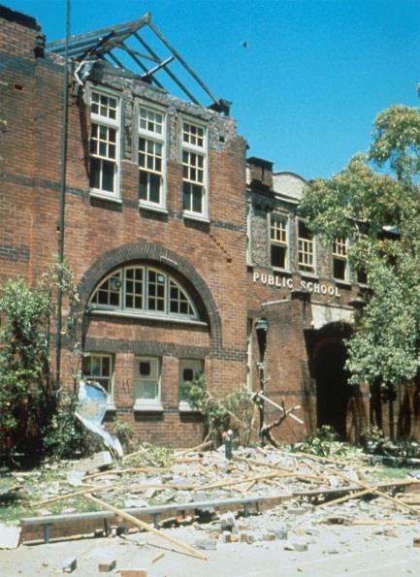

*Figure 19: Newcastle Public School after the 1989 earthquakeCadoux (magnitude 6.1) –Western Australia, 2 June 1979*

## Tennant Creek (magnitudes 6.2, 6.3 and 6.6) – Northern Territory, 22 January 1988

A series of three powerful earthquakes with magnitudes of 6.2, 6.3 and 6.6 shook the region within a twelve-hour period on 22 January 1988. Large ground ruptures caused severe warping to a major natural gas pipeline and a 35-kilometre long fault **scarp** formed with up to two metres of vertical displacement. Foreshocks started a year before the three large earthquakes, and thousands of aftershocks followed over the next few years.

## Cadoux (magnitude 6.1) –Western Australia, 2 June 1979

A 6.1 magnitude earthquake on 2 June 1979 caused surface faulting (Figure 20), with many homes and buildings damaged or destroyed. Despite the wreckage to the township of Cadoux, population 36, only one person was injured. Damage occurred to roads, railway lines, pipes and power lines. Some buildings 180 kilometres away in Perth also sustained structural damage.

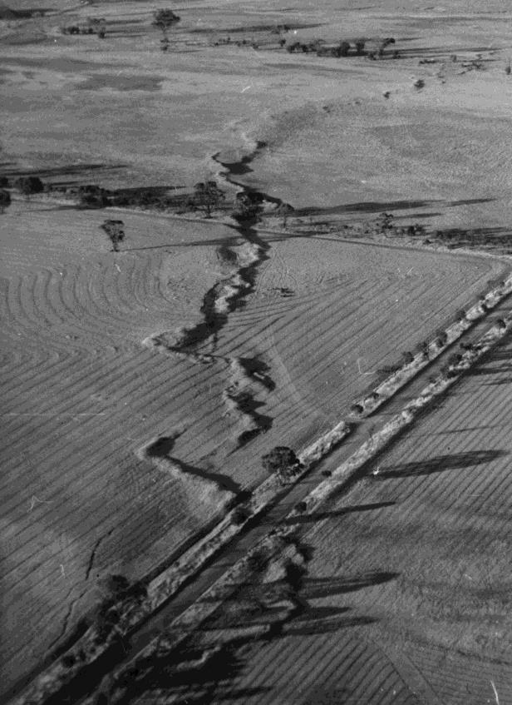.

*Figure 20: Surface rupture (top to bottom of image) resulting from the Cadoux earthquake.*

## Meckering (magnitude 6.5) – Western Australia, 14 October 1968

The magnitude 6.5 Meckering earthquake of 14 October 1968 was the largest in Western Australia's recorded history and the most significant in terms of damage. It caused a surface displacement, which ruptured the ground over a distance of about 40 kilometres. Buildings in Meckering were severely damaged, including 60 of 75 houses, a bank, hotel, shire hall and three churches. The fault disrupted the main highway, railway line (Figure 21) and water pipeline causing considerable displacement of the ground surface with up to 1.5 metres of vertical offset.

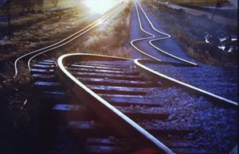

*Figure 21: Buckled railway lines from 1968 earthquake in Meckering, WA. Source: Alice Snook*

## Adelaide (magnitude 5.4) – South Australia, 1 March 1954

A magnitude 5.4 earthquake on 1 March 1954 in Adelaide was the first felt earthquake recorded in that city in almost 100 years. It resulted in three serious injuries and damage to 3000 buildings, including collapsed and cracked walls, smashed windows and collapsed chimneys, and 30 000 insurance claims were filed (Figure 22). A magnitude 3.2 aftershock was felt two days later.

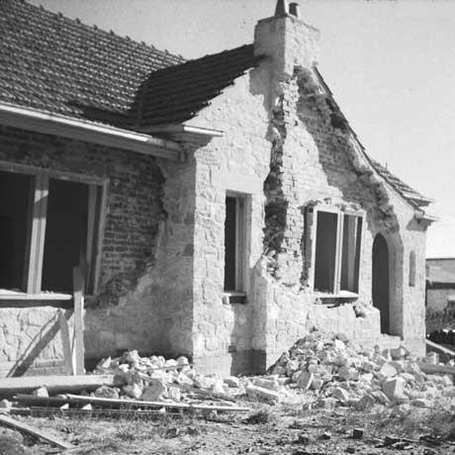

*Figure 22: Damage to a house in Seacombe Park after Adelaide earthquake, 1954. Source: PIRSA (Department of Primary Industries and Resources of South Australia)*

## West Tasman Sea (magnitude 5.8) - Tasmania, 14 September 1946

The largest southeastern Australian earthquake last century occurred 100 kilometres east of Flinders Island on 14 September 1946. Its magnitude was 5.8 and it was felt strongly throughout Tasmania and Gippsland, Victoria. It caused minor damage in Launceston, where a hotel guest was slightly injured.

## Meeberrie (magnitude 6.3) - Western Australia, 29 April 1941

The Meeberrie earthquake was felt over a wide area of Western Australia from Port Hedland in the north to Albany and Norseman in the south. The population near the epicentre was sparse, so the damage was limited, but it cracked all walls of Meeberrie Homestead, burst rainwater tanks and cracked the ground.

## Dalton-Gunning (magnitude 5.6) – New South Wales, 19 November 1934

A magnitude 5.6 earthquake occurred on 19 November 1934. It was preceded by a week of foreshocks and was followed by a long series of aftershocks. It was felt widely over southeastern New South Wales with the worst damage in Gunning where trees were felled, rocks split, fissures opened in the ground and almost all stone and masonry buildings were damaged. Damage was also extensive at Dalton. This earthquake, which occurred about 60 kilometres north of Canberra, had the same magnitude as Australia’s most damaging earthquake, the notorious 1989 Newcastle earthquake.

## Bundaberg (magnitude 6.0) Queensland, 7 June 1918

A magnitude 6.0 earthquake occurred on 7 June 1918 and is the largest known Queensland earthquake. The epicentre was probably about 100 kilometres off the coast between Rockhampton and Gladstone. The earthquake was felt from Mackay to Grafton (NSW) and west to Charleville. It caused some damage in Rockhampton and Bundaberg, and stopped many clocks, including the one in the Pile Light in Brisbane, where it was felt in most suburbs.

## Warooka (magnitude 6.0) – South Australia, 19 September 1902

A magnitude 6.0 earthquake is the second largest known South Australian earthquake. The epicentre was probably in the Gulf St Vincent between Warooka and Adelaide. It caused significant damage to several stone and masonry buildings in Warooka, including a school, and was the first earthquake to do damage in Adelaide.

## Beachport (magnitude 6.5) – South Australia, 10 May 1897

The largest known South Australian earthquake had a magnitude of 6.5. It occurred just off the coast between Beachport and Robe on 10 May 1897. It was felt throughout southern South Australia and in southwestern Victoria, and caused liquefaction at Robe, Beachport and Kingston, with sand volcanoes and water spouts. Kingston felt around 90 aftershocks following the two days after the earthquake.

## West Tasman Sea Swarm (magnitude 6.3-6.9) – Tasmania, between 1883 and 1892

Between 1883 and1892, around 2000 earthquakes occurred off the north-eastern coast of Tasmania, in the west Tasman Sea, mainly to the east of Flinders Island. These were felt in north-east Tasmania and in the islands off the coast. The three events, in July 1884, May 1885 and January 1892, had estimated magnitudes of 6.3, 6.6 and 6.9. All three quakes caused damage in Launceston and were felt over most of Tasmania, in southeast Victoria and the far southeast of New South Wales.

## Sydney (approximate magnitude 5) – New South Wales, 22 June 1788

The earliest recorded earthquake in Australia occurred just five months after the First Fleet landed at Sydney Cove. Below are the recorded descriptions of the event:

*"On the afternoon of 22 June [1788], a brief tremor ran through the settlement. It came, said young David Blackburn, master of the Supply, living ashore, 'from the south-west like the wave of the sea, accompanied by a noise like a distant cannon. The trees shook their tops as if a gale of wind was blowing.'*

*“This shock was distinctly felt on board the ships in the cove and by several people on shore, who supposed it to be the shock of an earthquake."* (Bradley 1802). (Figure 23)

*"On the 22nd of June was a slight shock of an earthquake, which did not last more than two or three seconds. It was felt by most people in the camp, and by the Governor himself, who heard at the same time a noise from the southward, which he took at first for the report of guns fired at a great distance."* from “The Voyage of Governor Phillip to Botany Bay” by Arthur Phillip in 1789.



*Figure 23: Cover of a book containing the quote by Bradley. Source:* [*http://www.scribd.com/doc/90060186/A-*](http://www.scribd.com/doc/90060186/A-Commonwealth-of-Thieves-The-Improbable-Birth-of-Australia)[*Commonwealth-of-Thieves-The-Improbable-Birth-of-Australia.*](http://www.scribd.com/doc/90060186/A-Commonwealth-of-Thieves-The-Improbable-Birth-of-Australia)

# Australia's earthquake record in the pre-instrumental era

The Meckering earthquake of 1968 is the second largest earthquake recorded on the Australian continent. Such events are rare in the historical record, which spans the two centuries since European settlement. This is because large earthquakes on active faults in Australia occur at long intervals of tens to hundreds of thousands of years or more. The historic record is not long enough for us to assess what the maximum magnitude of earthquakes in Australia is likely to be, and which regions are most prone to large damaging earthquakes. To address this problem, Geoscience Australia uses **paleoseismology** techniques to extend the historic record of earthquakes back tens of thousands of years.

The standard way of obtaining data on the locations and frequency of large, destructive earthquakes is to look for evidence in the landscape. Some faults that have had a large earthquake often cause a displacement of the land surface that forms a **scarp**, and the length of this fault scarp is proportional to the **paleoearthquake** magnitude. Once a scarp has been identified, soil and rock layers displaced across the fault can be mapped and dated to work out the displacement (an indication of the earthquake magnitude) and the ages of large earthquakes. If there are undisturbed layers covering the fault they can be dated to indicate the amount of time since the last earthquake.

However, fault scarps are often difficult to recognise in the landscape and the vastness of the Australian continent limits the effectiveness of traditional methods used to identify these features, such as aerial photographs. High-resolution digital elevation models have recently emerged as an important tool for finding fault scarps (Figure 24) and are well suited to exploration over large or remote areas. This topographic data may be gathered by satellite or aerial surveys.

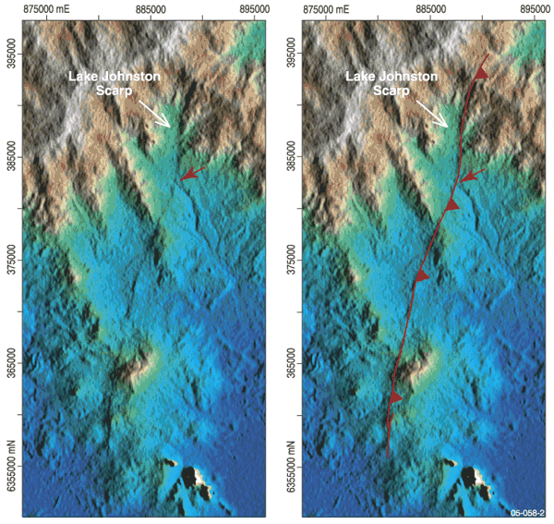

*Figure 24: Recent fault scarp revealed by Shuttle Radar Topography Mission DEM*

Examination of digital elevation models of the southwest of Western Australia enabled the identification of 33 previously unrecognised fault scarps which are probably Quaternary age (within the last 2.6 million years) (Figure 25). This finding more than doubles (to 60) the number of Quaternary scarps known in this area. The features are between 15 kilometres to 45 kilometres long and between

1.5 metres to 20 metres high. The scarp from the 1968 Meckering earthquake (magnitude 6.5) is 37 kilometres long and only two metres high, which suggests that some of the newly discovered features may have been associated with significantly larger earthquakes, and/or multiple earthquakes.

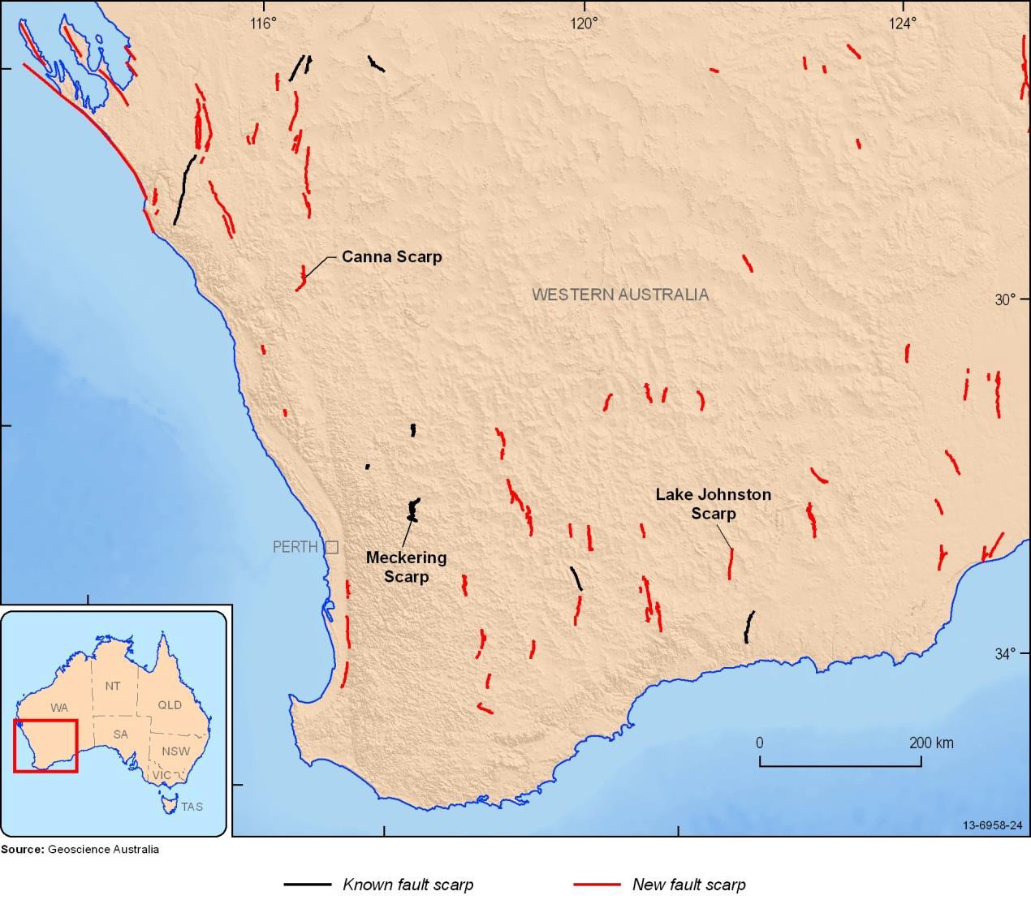

*Figure 25: Fault scarps that have been active within the last 26 million years in southwest Western Australia.*

The new fault scarp data allow estimates to be made of the maximum magnitude earthquake which is possible in this region. It is important to know this magnitude as it is used to estimate the earthquake hazard. This in turn is used to develop building codes, which include earthquake resistance. Furthermore, the identification of regions where earthquakes are more likely to occur allows emergency managers and planners to educate the local community and develop effective strategies to respond to, and moderate, the impact of earthquakes.

## Lake Edgar – Tasmania, 20 000 years ago

One prominent Quaternary scarp relates to the Lake Edgar Fault in southwest Tasmania (Figure 26). The 30 kilometre long north-south oriented scarp occurs within the Southwest National Park. The scarp crosses the Huon Plains and is of note because the fault resulted in the damming of westerly flowing drainage and thus the formation of Lake Edgar. Recent research indicates this fault scarp is the result of a magnitude 6.5 to 7.0 earthquake.

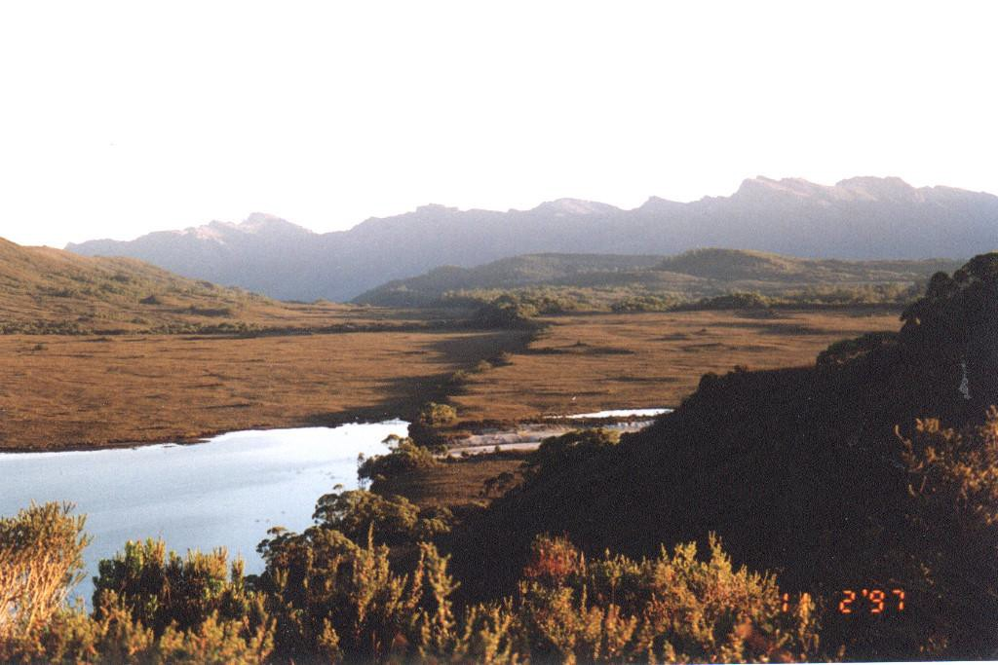

*Figure 26: Lake Edgar Fault scarp, Tasmania. The scarp has dammed a creek to form the lake to the left.*

# The impact of earthquakes in Australia

The 1989 earthquake in Newcastle ,New South Wales demonstrated that earthquakes in Australia can result in significant losses to our communities, in terms of both human fatalities and damage to the built environment (Figure 27). This devastating event showed that Australian communities are vulnerable to earthquake hazards and need to be better prepared.

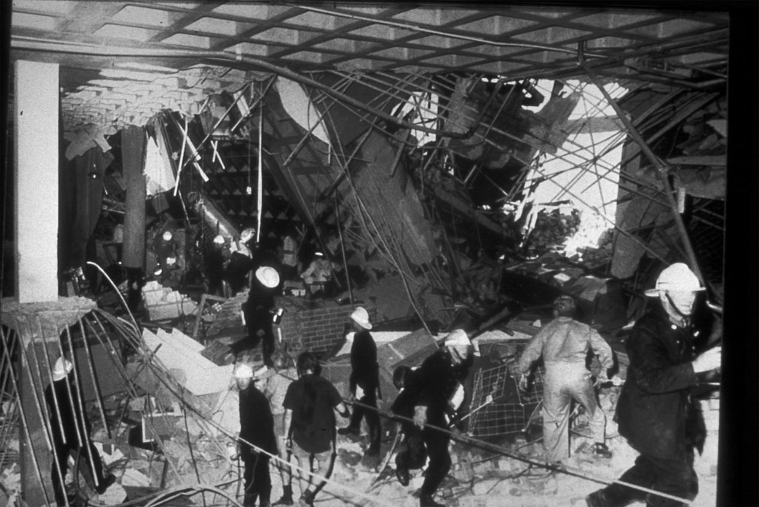

*Figure 27: Newcastle earthquake damage.*

Records of past earthquakes helps to estimate the possible locations, magnitudes and characteristics of Australian earthquakes that may occur in the future. Estimates are then made of the amount of energy that is absorbed by the rocks as the seismic waves pass through them as they travel from the earthquake focus to the ground surface. This is done using data gathered from previous earthquakes and by considering the regional geology. As a general rule, seismic waves travel fast with low amplitude through rock, and slow down and increase in amplitude when passing through shallow sediments, soil and weathered rock. For instance, much of Newcastle is on unconsolidated sediments so the shaking due to the 1989 earthquake was amplified.

To assess the impact of earthquakes in Australia scientists must estimate the level of ground shaking which is likely to occur due to earthquakes. The amount of ground shaking depends on the size and distance of the earthquake, and how much of the energy is absorbed by the rocks and soils between the earthquake and the building (Figure 28). This information can be used to consider the likely effect this ground shaking would have on the buildings and other infrastructure that would be exposed to it. The potential for damage on the building from such shaking depends on the type of building construction and the local site conditions.

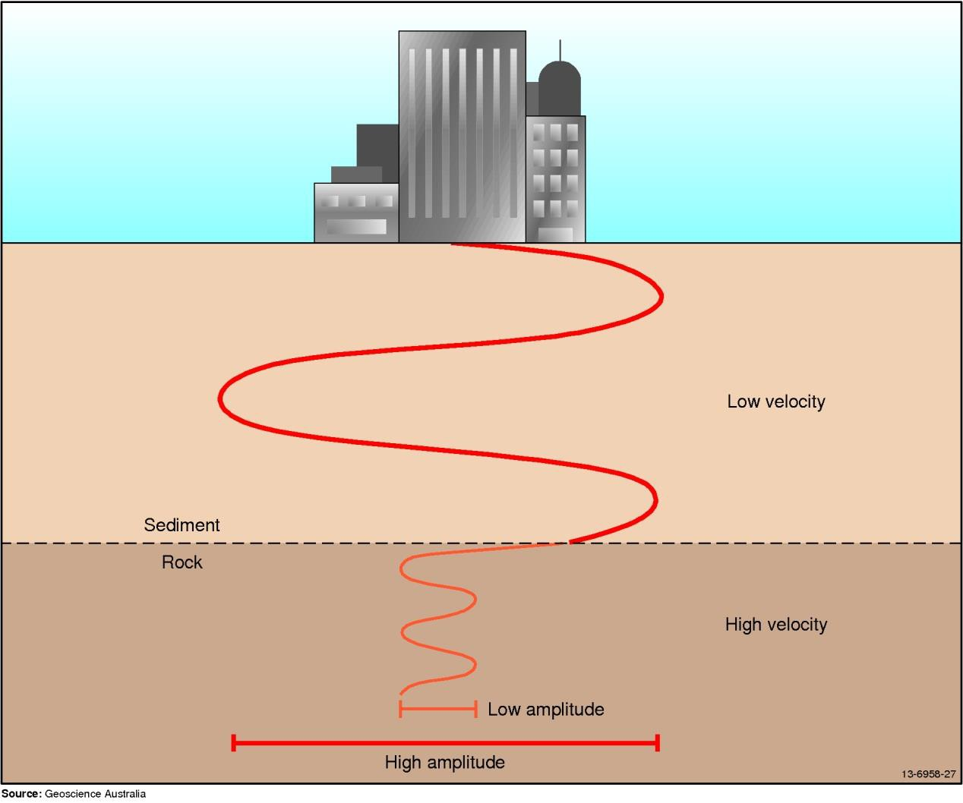

*Figure 28: Propagation of earthquake energy through the earth, showing the effect of moving from high velocity (‘fast’) rock into lower velocity (‘slow’) sediments and soils. This change can amplify the shaking.*

# Case study: Cadell fault (NSW/Vic border)

The Cadell Fault scarp is situated along the NSW-Victorian border, between Echuca and Deniliquin. The scarp is almost 80 kilometres long and the land to the west of it is up to 15 metres higher than land to the east (Figure 29). It was formed by movement on the Cadell Fault 70 000 – 20 000 years ago, which would have been accompanied by at least five earthquakes, estimated to have had magnitudes of 7.0 to 7.3. The scarp crossed the original course of the Murray River, forming a dam across it and causing a lake to form on its eastern side. Later earth movements diverted the Murray River south to its present course through Echuca and eventually drained the lake.

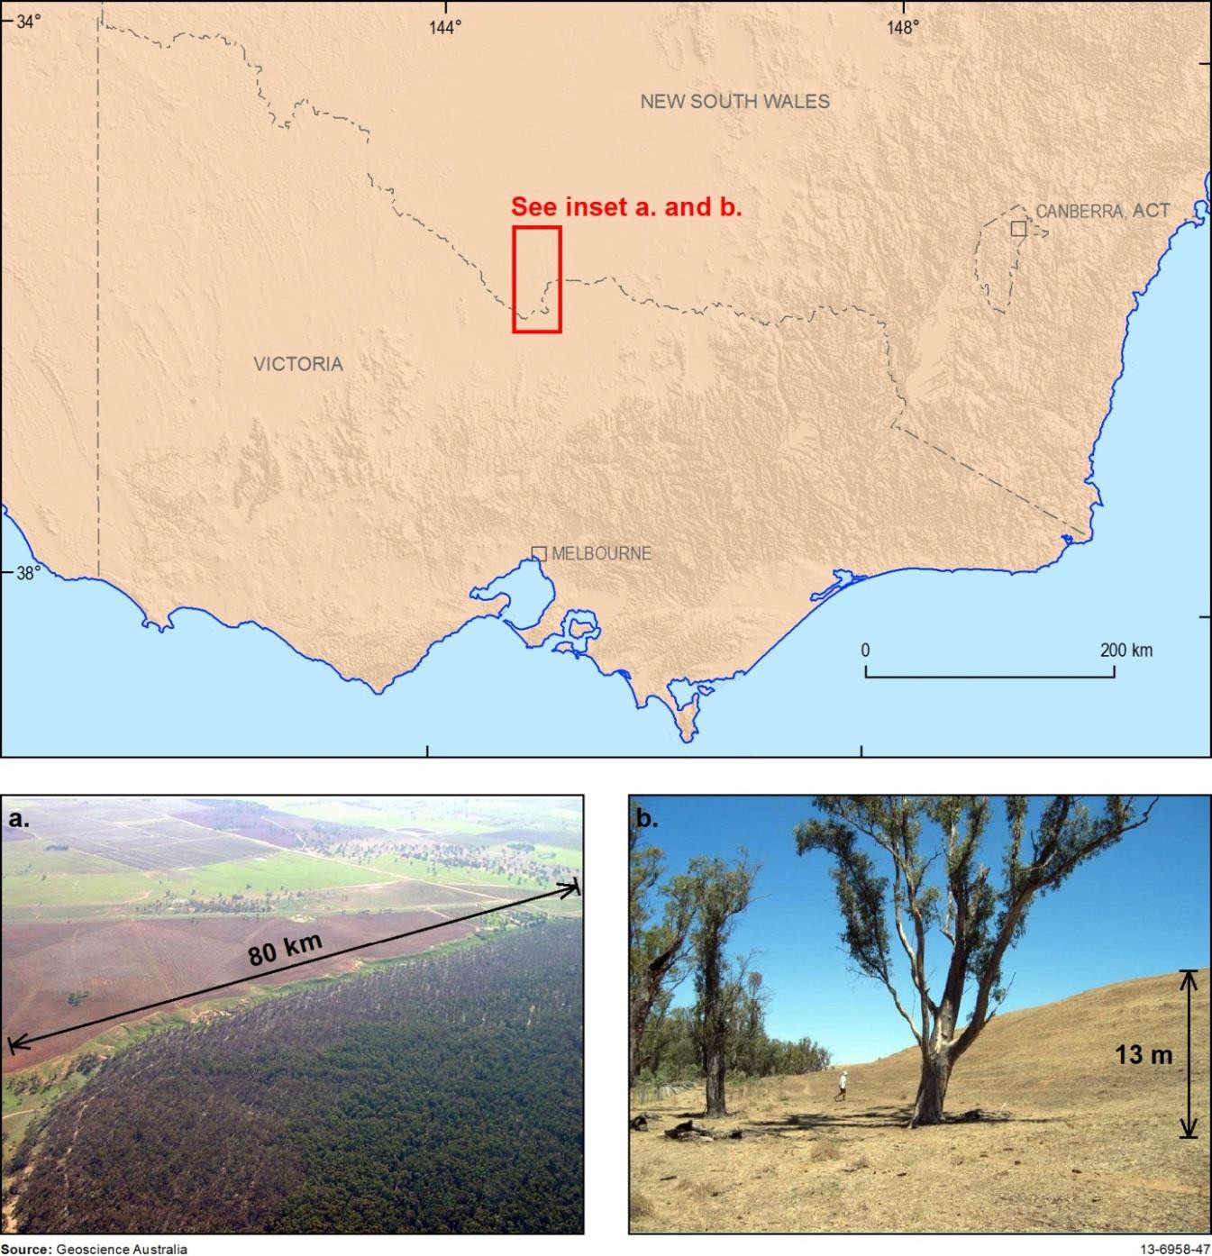

*Figure 29: Map of Victoria showing location of Cadell Fault. a) Aerial photograph of fault, b) ground level photograph of fault scarp.*

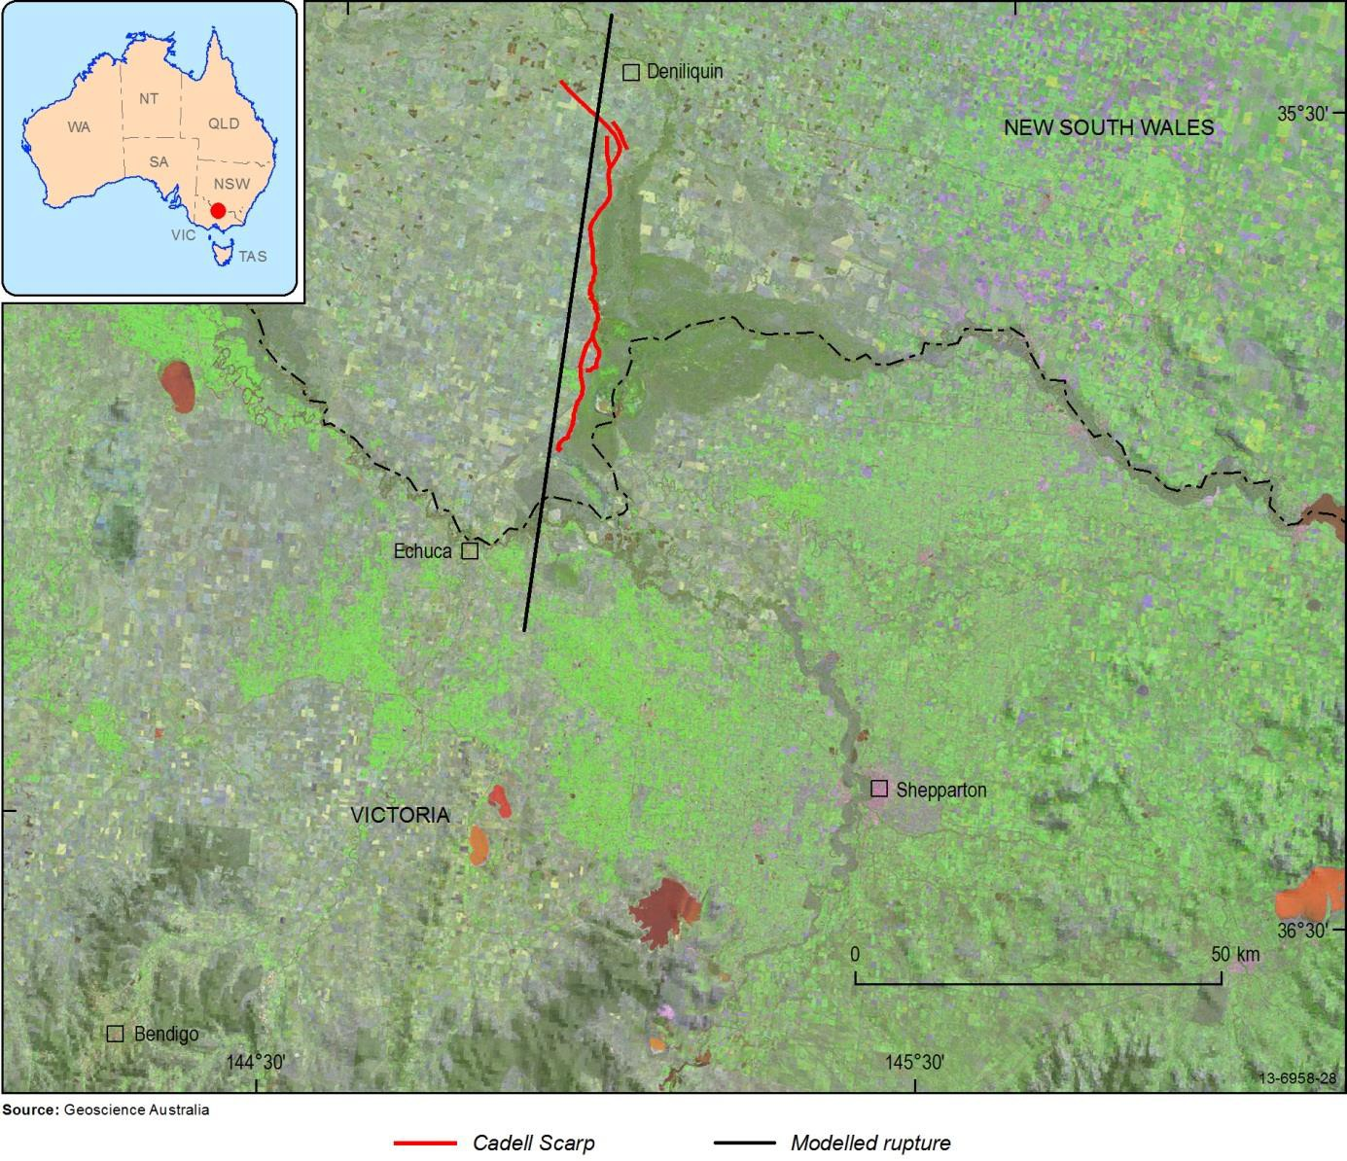

*Figure 30: Map showing where the Cadell scarp is in relation to Echuca and Deniliquin. Cadell Fault scarp (wiggly red line) and the modelled rupture (straight black line).*

Estimating the effects of an earthquake on the Cadell Fault3

There are four significant towns (Bendigo, Shepparton, Echuca and Deniliquin) close to the Cadell Fault. For the locals living in the region of the fault, large earthquakes represent a major potential hazard to communities and infrastructure.

By combining information on the historical behaviour of the Cadell Fault, estimates of how much energy would travel through rocks in the area, and calculating the amplification effects that soils and sediments have on the seismic waves, scientists can develop a model to show how much ground shaking is likely to occur during an earthquake.

Figure 31 shows one possible estimate of the impact for a magnitude 6.8 and 7.2. earthquake . However, continuing research is improving our knowledge of the way seismic energy is transmitted through sediments and soils, which will be used to fine-tune our current estimates. The results of this

1. To learn more about the Cadell Fault, visit Geoscience Australia’s hazard webpages: [http://www.ga.gov.au/hazards/our-](http://www.ga.gov.au/hazards/our-capabilities/case-studies/another-earthquake-in-the-cadell-fault-scarp.html) [capabilities/case-studies/another-earthquake-in-the-cadell-fault-scarp.html](http://www.ga.gov.au/hazards/our-capabilities/case-studies/another-earthquake-in-the-cadell-fault-scarp.html)

modelling can be used to improve building codes and by emergency managers to plan for disasters and optimise emergency response.

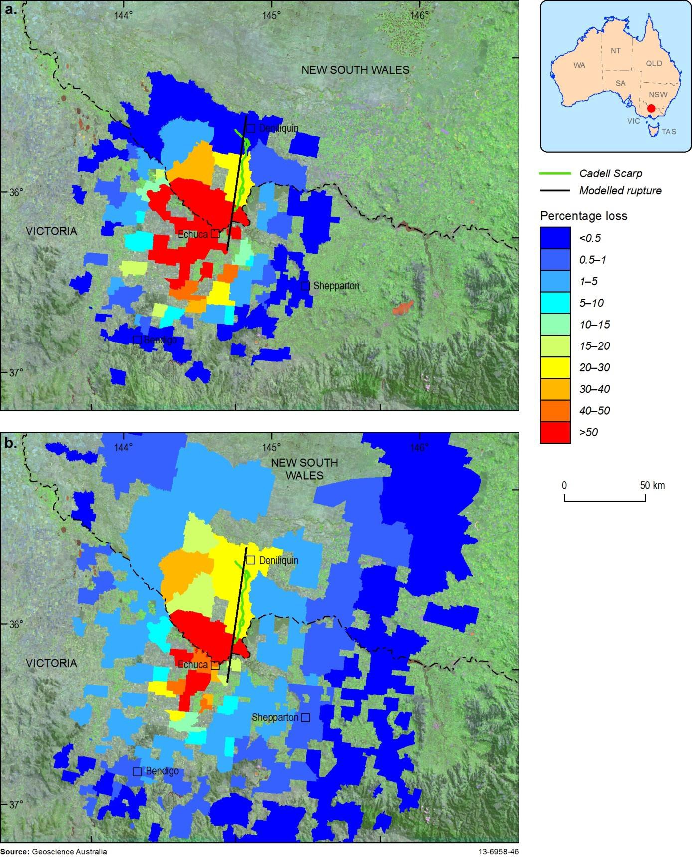

*Figure 31: Modelled ground shaking from earthquakes of (a) magnitude 6.8, and (b) magnitude 7.2. These are the maximum credible earthquake (magnitude 7.2) and the smaller but potentially more frequent earthquake (magnitude 6.8).*

# Earthquake monitoring

Geoscience Australia operates a 24/7 earthquake monitoring centre which detects, analyses and reports on earthquakes within Australia and internationally (Figure 32). This centre is part of the Joint Australian Tsunami Warning System, which provides a warning if an earthquake has the potential to cause a tsunami. It also provides alerts when earthquakes occur in Australia and for larger earthquakes which occur overseas.



*Figure 32: Australian Tsunami Warning Centre at Geoscience Australia.*

Earthquakes located in Australia, and earthquakes with a magnitude of 5 or greater outside Australia but within our region, are catalogued and published on the Geoscience Australia website. Earthquakes occurring anywhere in the world with a magnitude of 6 or greater are also catalogued and published on the Geoscience Australia website.

Geoscience Australia operates the Australian National Seismic Network which monitors seismic data from over 60 stations in Australia (Figure 33). The data are sent to the processing centre in Canberra in **near-real time**; that is, they arrive within about 10 seconds of being recorded at the seismometer. Data are also obtained in near-real time from over 130 stations belonging to overseas national seismic networks. The data are analysed automatically and reviewed by a **seismologist**. The results are posted on the Geoscience Australia website within about 15 minutes of the earthquake's origin time

1. the time when the earthquake occurred).

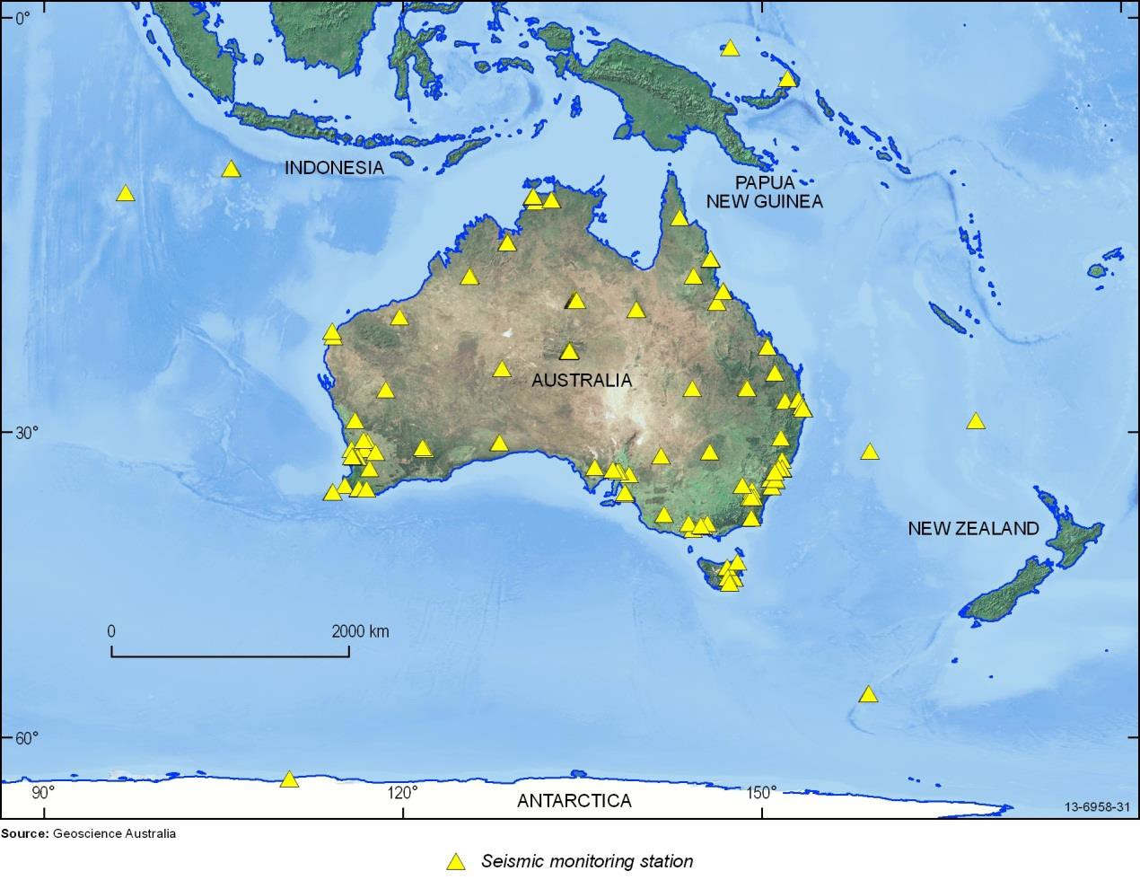

*Figure 33: Australian National Seismograph Network Stations represented by yellow triangles.*

# The tsunami warning system

The Joint Australian Tsunami Warning Centre (JATWC) is operated by the Bureau of Meteorology and Geoscience Australia. Based in Melbourne and Canberra, the JATWC was established so that Australia has an independent capability to detect, monitor, verify and warn the community of a tsunami in our region and, of possible threats to Australian coastal locations and offshore islands.

Using seismic and sea level monitoring and warning systems the JATWC provides a 24 hour tsunami monitoring and analysis capacity for Australia.

The major objective of the JATWC is to provide Australian emergency managers with a minimum of 90 minutes warning of a likely tsunami impact generated from subduction zone earthquakes. The JATWC is a long-term investment in effective emergency management and has the real potential to save lives and infrastructure.

The JATWC is the core component of the Australian Tsunami Warning System (ATWS). Other contributors to the ATWS include the Attorney-General’s Department through its role in public education and support for state emergency service organisations who respond to tsunami warnings by arranging evacuations. To be considered as a possible tsunami-generating earthquake three factors have to be checked:

* 1. Did the earthquake occur beneath the ocean (or very close to the shore)?
  2. Was the magnitude above 6.5?
  3. Was the depth less than 100 kilometres?

After an earthquake is detected, the relevant seismic data are analysed by specially designed automatic systems that form part of the 24 hour operations centre. Once alerted by the system the Duty Seismologists at Geoscience Australia determine the potential for the detected earthquake to cause a tsunami by further analysing the seismic information.

The JATWC also receives data from the Bureau of Meteorology’s sea level observations. Highly sensitive instruments provide real-time sea level observations that can verify whether an earthquake has generated a tsunami as well as monitoring its path. The data are provided by sea-level stations along coasts and deep-ocean tsunami detection (DART) buoys. Utilising the sea level data and scientific modelling, specially trained staff then issue a warning based on the model. The warning provides an estimate of the time of arrival of the first tsunami wave and threat level. This process is outlined in Figure 34.

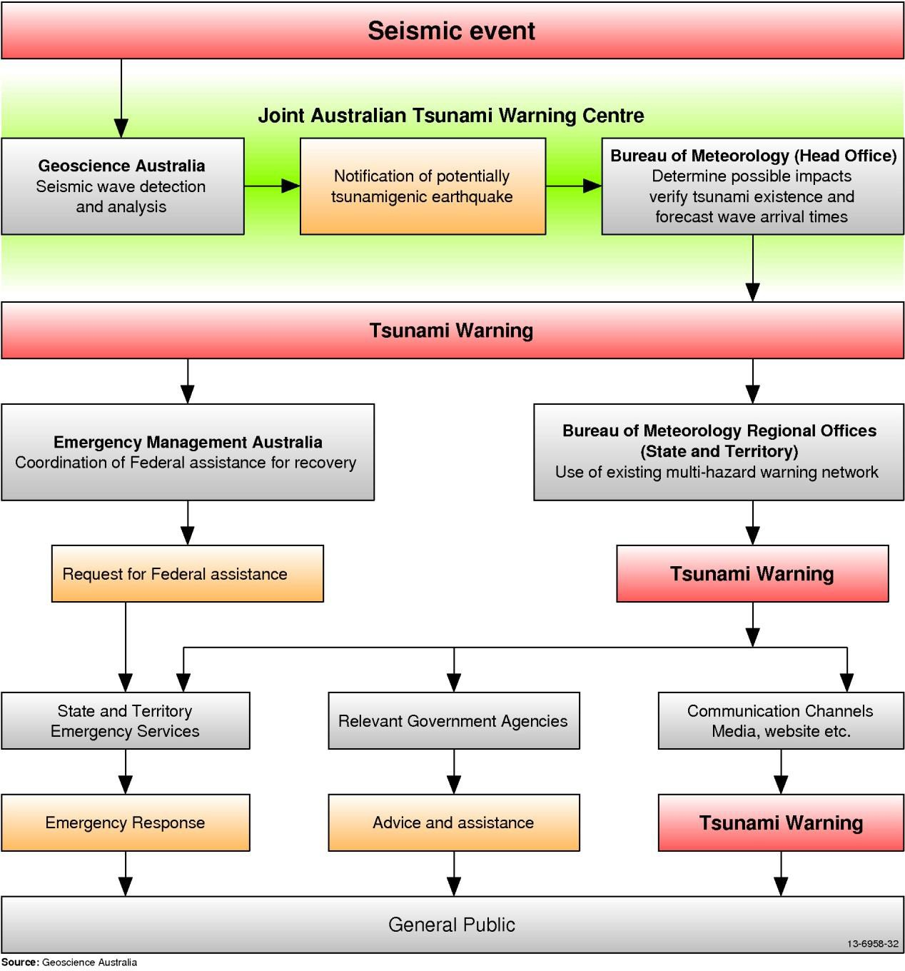

*Figure 34: A flowchart of activity to take place following a seismic event.*

**Activity: Earthquake Hazard Map**

# Websites for further information

Incorporated Research Institutions for Seismology (IRIS)

Comprehensive site with animations of earthquakes and a live world map showing locations and magnitudes of earthquakes in real time.

<http://www.iris.edu/hq>

IRIS website

The “Teachable Moments” section of the IRIS website has Web 2.0 and PowerPoint accessible information on recent, significant earthquakes.

<http://www.iris.edu/hq/retm/event/1328>

IRIS has quality, informative and colourful posters on earthquake topics such as the history of seismology and the physics of seismic waves.

<http://www.iris.edu/hq/publications/posters>

## Up-to-date earthquake data from specific countries:

British Isles and general information on earthquake science, British Geological Survey Earthquakes

<http://www.earthquakes.bgs.ac.uk/>

Canada, Natural Resources Canada

[http://www.earthquakescanada.nrcan.gc.ca](http://www.earthquakescanada.nrcan.gc.ca/)

New Zealand, GeoNet New Zealand *(highly recommended)*

<http://www.geonet.org.nz/earthquake/index.html>

United States, U.S. Geological Survey Earthquake Hazards Program

<http://earthquake.usgs.gov/>

South Australia, Primary Industries and Resources South Australia

<http://www.pir.sa.gov.au/minerals/earthquakes/>

Western Australia: Seismicity of Western Australia – The University of Western Australia:

<http://www.seismicity.see.uwa.edu.au/>

South East Queensland, Earth Systems Science Computational Centre Seismological Observatory,

University of Queensland

<http://www.quakes.uq.edu.au/>

Australian Tsunami Warning Centre, Bureau of Meteorology

<http://www.bom.gov.au/tsunami/about/jatwc.shtml>

Have you ever visited Geoscience Australia’s website?

<http://www.ga.gov.au/education>

# Glossary

**Asthenosphere** The highly viscous, ductile layer in the upper parts of the mantle, below the lithosphere, beginning at depths of 100 – 200 km and extending to as deep as 700 km.

**Aftershocks** The smaller earthquakes that may occur for months or years after the mainshock. These earthquakes are caused by the mainshock area re- adjusting to the fault movement and some may be the result of continuing movement along the same fault.

**Amplitude** The amount of change between the peak and trough of a wave.

**Bedrock** The solid rock buried beneath regolith.

**Earthquake swarm** A series of earthquakes in a localised area which may last for days or even months. None of the earthquakes are noticeably larger than the others, so there is no mainshock that distinguishes swarms from foreshock and aftershock sequences.

**Epicentre** The point on the earth’s surface that is directly above the earthquake’s focus.

**Fault** A crack or fracture in which the rocks on either side of the fracture are displaced relative to each other.

**Focus** The point on the fault plane where rupture began. It is also known as the hypocentre. This point is defined by latitude, longitude, and depth.

**Foreshocks** Smaller earthquakes that precede by up to a year a larger earthquake. They are caused by minor fracturing of rocks under stress prior to the largest earthquake of the series, called the mainshock.

**Interplate earthquakes** Earthquakes that occur along the margins of tectonic plates.

**Intraplate earthquakes** Earthquakes that occur in the interior of tectonic plates, far from the plate margins.

**Landslides** The movement of rock, debris or earth down a slope. Landslides are also known as landslips, slumps or slope failure.

**Liquefaction** The transformation of loose sediment or soil into a fluid state as a result of increasing the pressure of the fluid in between the grains due to strong ground shaking. Liquefaction typically occurs in poorly consolidated, water- saturated sediment.

**Lithosphere** The outer part of the earth, consisting of the crust and upper mantle, approximately 100 kilometres thick. The lithosphere is broken into several large and many small plates called tectonic plates.

**Mainshock** The largest earthquake in a series of earthquakes that cluster, both geographically and in time. To be definitively called a mainshock, the earthquake should generally be at least half a magnitude unit larger than the next largest earthquake in the series. Otherwise, the series of earthquakes may be more accurately characterised as an **earthquake swarm.**

**Modified Mercalli** A measure of earthquake intensity scale with 12 divisions ranging from I (felt by very few) to XII (total destruction).

**Moment magnitude** The magnitude calculated from an earthquake's total energy (seismic moment). The seismic moment is proportional to the amount of slip on a fault, the area of the fault that slips, and the average strength of the rocks that are faulted. Because moment magnitude is directly related to the energy released by an earthquake, it is a uniform means of measuring earthquake magnitude and has become the standard measure of earthquake magnitude for larger earthquakes today.

**Near real-time** The time delay between the occurrence of an event and the arrival of the data on that event. For instance, seismic data is displayed at a central processing facility just a few seconds after the seismic waves are detected at a remote seismograph thousands of kilometres away.

**Normal fault** A fault in which the rocks on the upper side of the fault move downwards relative to the lower side due to tension in the Earth’s crust.

**Origin time** The time when an earthquake starts to occur, that is, when the fault starts to rupture.

P (primary or compressional) wave

The first type of earthquake wave (seismic wave) to arrive at a seismic station. The direction of vibration of the particles in the wave is the same as the direction in which the wave travels.

**Paleoearthquake** A pre-historic earthquake.

**Paleoseismology** The geological study of pre-historic earthquakes.

**Propagate** (in physics) Travel through a medium. For instance, the passage of seismic waves through the Earth.

**Reverse fault** A fault in which the rocks on the upper side of the fault are pushed up over the lower side due to compression in the Earth’s crust

**Richter Scale** Introduced in 1935 by Charles F. Richter and Beno Gutenberg, the Richter scale is based on a logarithmic expression that quantifies energy of an earthquake.

**Scarp** A slope or escarpment produced by faulting at the land surface.

S (secondary, shear or transverse) wave

The second type of earthquake wave (seismic wave) to arrive at a seismic station. The direction of vibration of the particles in the wave is perpendicular to the direction of travel of the wave.

**Seismic waves** Waves of energy that travel through the earth as a result of a disturbance on or within the earth, such as earthquakes, explosions or volcanoes.

**Seismogram** The graphed data of seismic events from measurements made by seismic sensors. Old records were recorded mechanically on paper, but modern records are recorded digitally. The seismogram’s x-axis usually represents time, while the y-axis records the amplitude of ground displacement, velocity, or acceleration.

**Seismograph** An instrument that detects and records earthquakes and other ground motions. This word is sometimes used interchangeably with ‘seismometer’.

**Seismologist** A geophysicist who uses seismic data to study earthquakes, map out the earth’s structure and find oil and mineral deposits.

**Seismometer** An instrument used to measure ground motion. When it is paired with a data recorder, it is referred to as a seismograph.

**Strike-slip fault** A fault which is oriented vertically, and in which the rocks on one side are displaced horizontally relative to the other side.

**Subduction zone** The zone of convergence of two tectonic plates, where one slides (subducts) beneath the other.

**Surface wave** A wave that travels along the interface between two different materials, e.g. along the Earth’s surface. In seismology, they are the most destructive type of wave, and can travel around the globe many times after a single large earthquake.

**Tectonic plates** Separate pieces of the Earth's outer layer (the lithosphere). These plates are on average 100 kilometres thick and are constantly moving towards, away from or past each other. There are seven large plates and numerous smaller plates around the world.

**Thrust fault** A reverse fault with a dip of less than 45°, in which the hanging wall (the upper block) moves up relative to the footwall (the lower block).

Topography (in earth science)

The hills, valleys and other variations in elevation that make up the shape of the earth’s surface.

**Tsunami** Tsunami (pronounced 'soo-nar-me') is a Japanese word with 'tsu' meaning harbour and 'nami' meaning wave. The wave is caused by earthquakes, landslides or volcanic eruptions that are under or next to large water bodies, such as the ocean, and that disturb the water to cause a series of waves. Asteroid impacts can also cause tsunami.

**Volcanic tremor** Bursts of continuous vibration caused by pressure changes in the rock from unsteady transport of magma in a volcano. May indicate a pending volcanic eruption.

Student Activities

Find Detritus!

Recommended Age: Upper primary / lower secondary Equipment needed:

* Pair of compasses

##### Tracy walked home from school one day and found a message pinned to her front door. The message said:



##### On the map of Quakeville, mark with a pencil where Tracy should go to look for Detritus. Think about what extra drawing implements would allow you to do this accurately. Tracy's house is labelled and the scale is on the bottom of the map.

##### HINT: Assume the dog has stopped now, but while it travelled it could jump fences, swim creeks etc. The dog could have travelled in any direction from Tracy's house.

##### Describe the shape of the area where Tracy needs to look to find her dog:

##### As Tracy leaves her front gate, she spies another note in her mailbox. The note says:

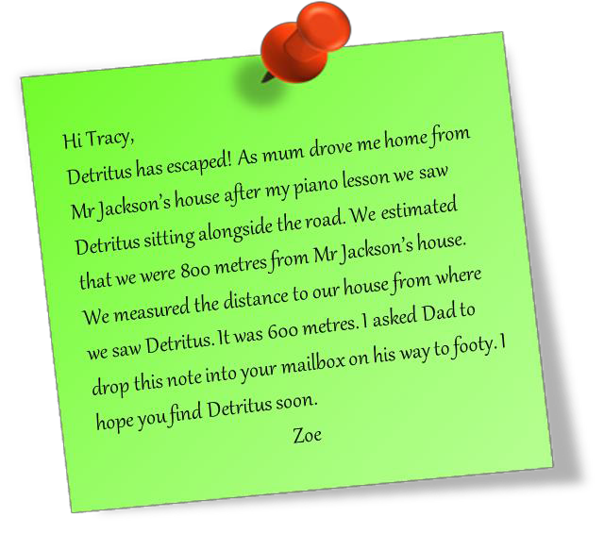

##### Using the map of Quakeville, work out where Tracy will find her escaped four-legged fugitive.

**Map of Quakeville**

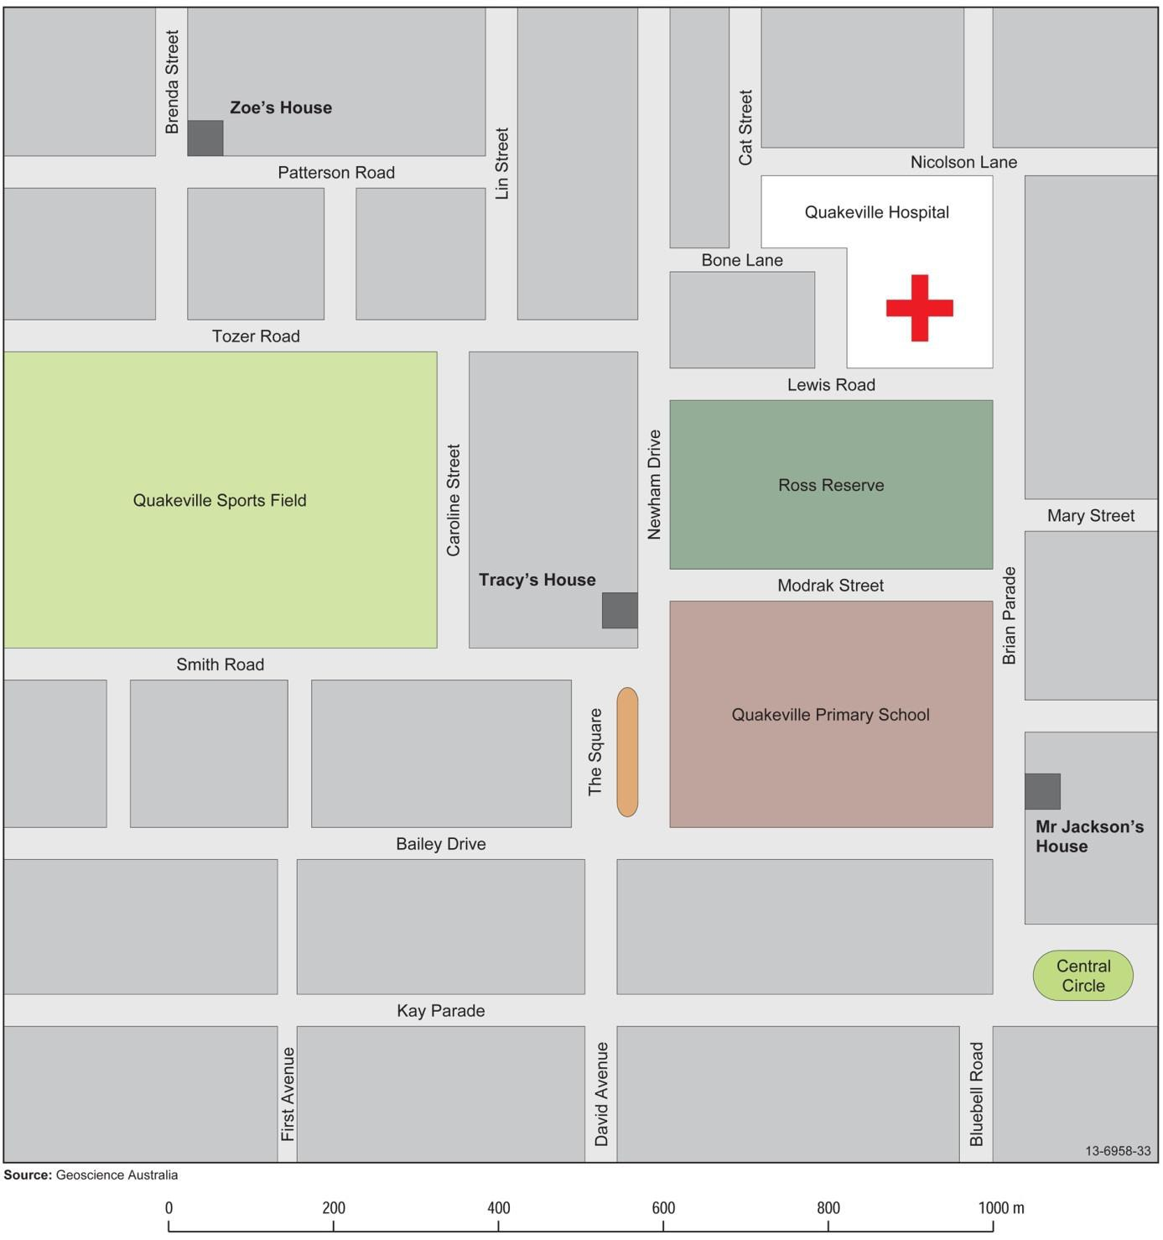

Epicentre hunt

Recommended Age: Middle to upper secondary Equipment needed:

* + Pair of compasses
  + Ruler with millimetre intervals marked

**The scenario**

While the people in the township and surrounding areas of Quakeville slept, a small earthquake shook the area. The tremor was so small that it was not felt be anyone, but it was recorded by seismometers in the five seismic stations in the area. Locals were wary of the tremor, because in the past, similar small tremors had always been recorded before more intense earthquakes occurring in the same spot.

You have been sent the seismograms from three stations. Can you predict where the epicentre of the next major earthquake may be?

Look at the Quakeville Station seismogram. The arrival of the P waves and the arrival of the S waves have been found and the number of seconds between them has been calculated (each mark represents one tenth of a second - so ten marks is one second).

Do the same procedure for the seismograms from the other four stations.

1. What are the differences in arrival time of the P and S waves for each station?

|  |  |  |
| --- | --- | --- |
| **Station** | **Difference in arrival time between P and S (sec)** | **Distance from epicentre (km)** |
| **a.** Quakeville Station | *6.0 seconds* | *53 km* |
| **b.** Pearsons Crossing Station |  |  |
| **c.** Well Station |  |  |

1. Using the time/distance graph, calculate the distance of the epicentre from each station.

HINT: To calculate the distance find the point on the graph where the line crosses the time for that station. Read straight down for the distance. You can use a ruler and a pencil to get accurate readings. Quakeville Station's distance is 53km. Check to see if you agree.

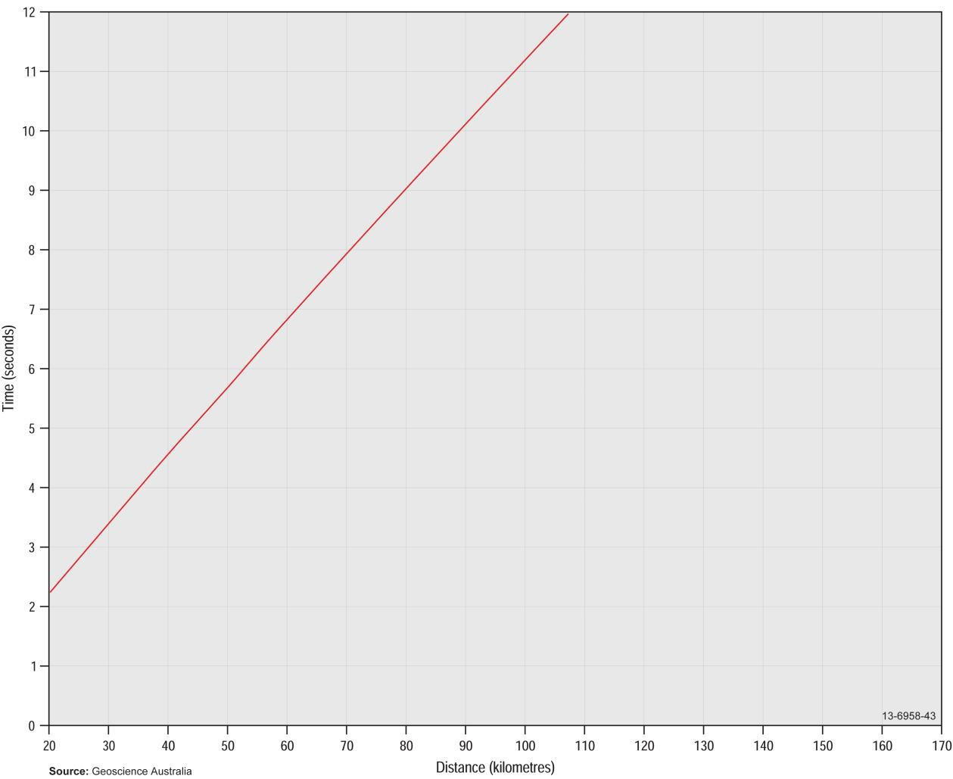

1. On the map of the Quakeville Area, use a pair of compasses to draw circles centred at each station. The radius of each circle will represent the distance that station was from the epicentre.
2. Mark an ‘X’ on the map where the epicentre was located. (Where the three circles overlap.)
3. How many townships or homesteads will be affected if a more intense earthquake follows this tremor? How did you choose these places?
4. What action could you take to warn people who may be affected without raising the alarm of other non-effected residents?

**EXTENSION**

1. Where possible a seismologist would use as many stations as possible. Two days later you visit the last two stations in the area to obtain the data manually from the seismometers. Repeat steps 1, 2 and 3 for the two new sets of data.

|  |  |  |
| --- | --- | --- |
| **Station** | **Difference in arrival time between P and S (sec)** | **Distance from epicentre (km)** |
| **d.** Upper Valley Station |  |  |
| **e.** Bucktown Station |  |  |

1. With this new data, has the accuracy of the epicentre location improved?

**Quakeville area seismic stations**

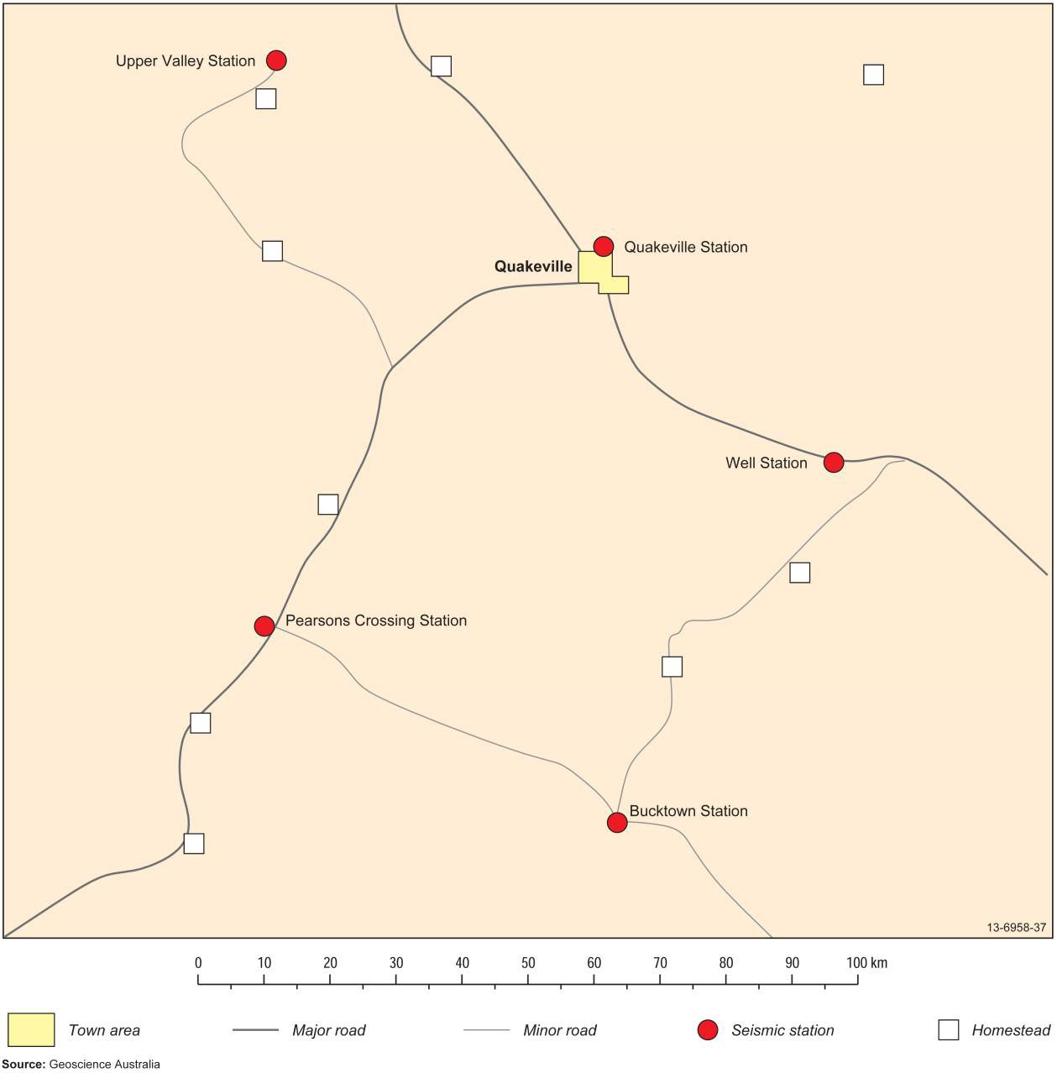

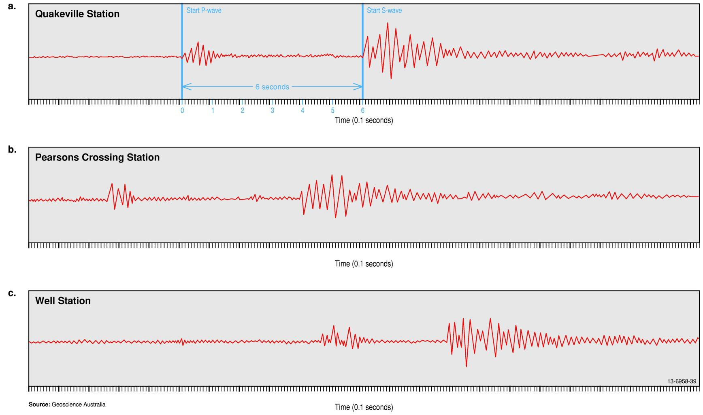

**Earthquakes – Teacher Notes and Student Activities 63**

**EXTENSION**

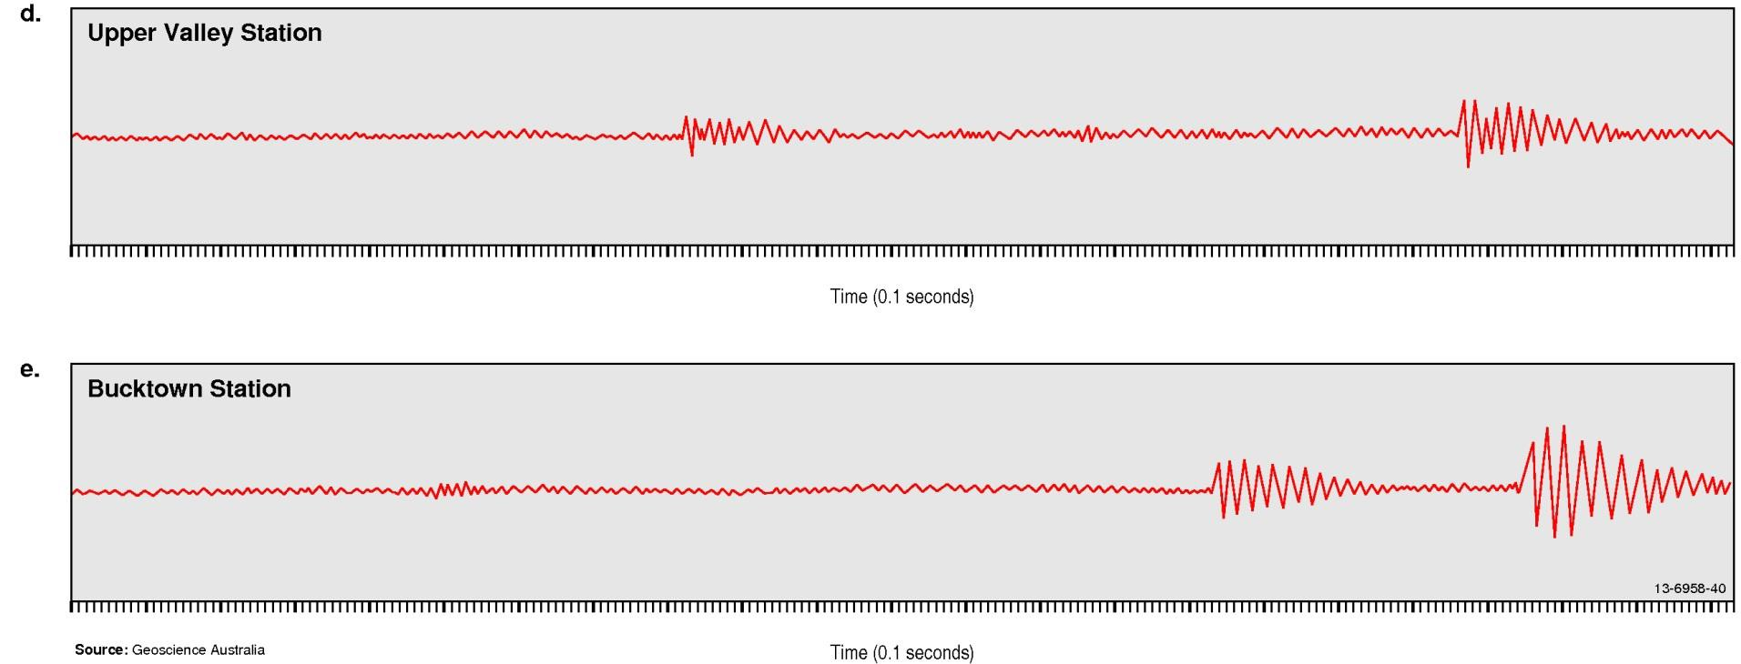

**64 Earthquakes – Teacher Notes and Student Activities**

Quakeville earthquake

Recommended Age: Middle to upper secondary

**NEWS FLASH**

* 1. *pm Reports have just come in that Quakeville has again been shaken by an earthquake. At this stage the extent of damage from the quake is unknown. Stay tuned for further reports throughout the evening….*

You are the reporter for the local newspaper and your editor wants you to write an item including a map for the next issue. You quickly look up the Twitter feed to learn what was felt and seen by locals at around 8.30 pm on the evening of the earthquake. (These comments are on separate sheets.) You also gather some background information about past earthquakes to include in your item.

**Background information**

Quakeville is often shaken by earthquakes. A large fault, known as the Crescent Fault, runs right under the town. The Crescent Fault is known to slip about once every ten years. The last earthquake was in 2005. No damage was done to any buildings. In 1942 an earthquake destroyed every brick house in town but no one was killed. It had a Modified Mercalli Intensity maximum of MM IX.

**Instructions**

* + 1. Using a Modified Mercalli Scale (page 69), work out the MM number for each of the eyewitness accounts you gathered and write it next to the comment.
    2. What was the greatest intensity (MM number) for this earthquake:
    3. Using the map and grid references provided, find each location and write the MM number in a small circle on the map.

*Scientists* often use "contours" to show features other than height above sea-level.

*Seismologists* often use "contours" to show lines of equal earthquake intensity on a map. These lines are called iso-seismal lines where ‘iso’ means ‘the same’ and ‘seismal’ refers to earthquakes.

* + 1. Draw iso-seismal lines (circular shapes separating areas of equal intensity) on your map using the MM numbers you have plotted.

HINT: Draw a line so that no MM number falls inside it other than the highest MM number for the earthquake. Next, draw a line so the next lowest MM numbers fall between it and the first line and so on.

NOTE One person is very unreliable - you will have to ignore his information!

* + 1. Write a brief article for the newspaper which contains the background information, your map and an explanation of what your map shows. Use a catchy headline. The whole article should be less than 200 words.

**Map of Quakeville region**

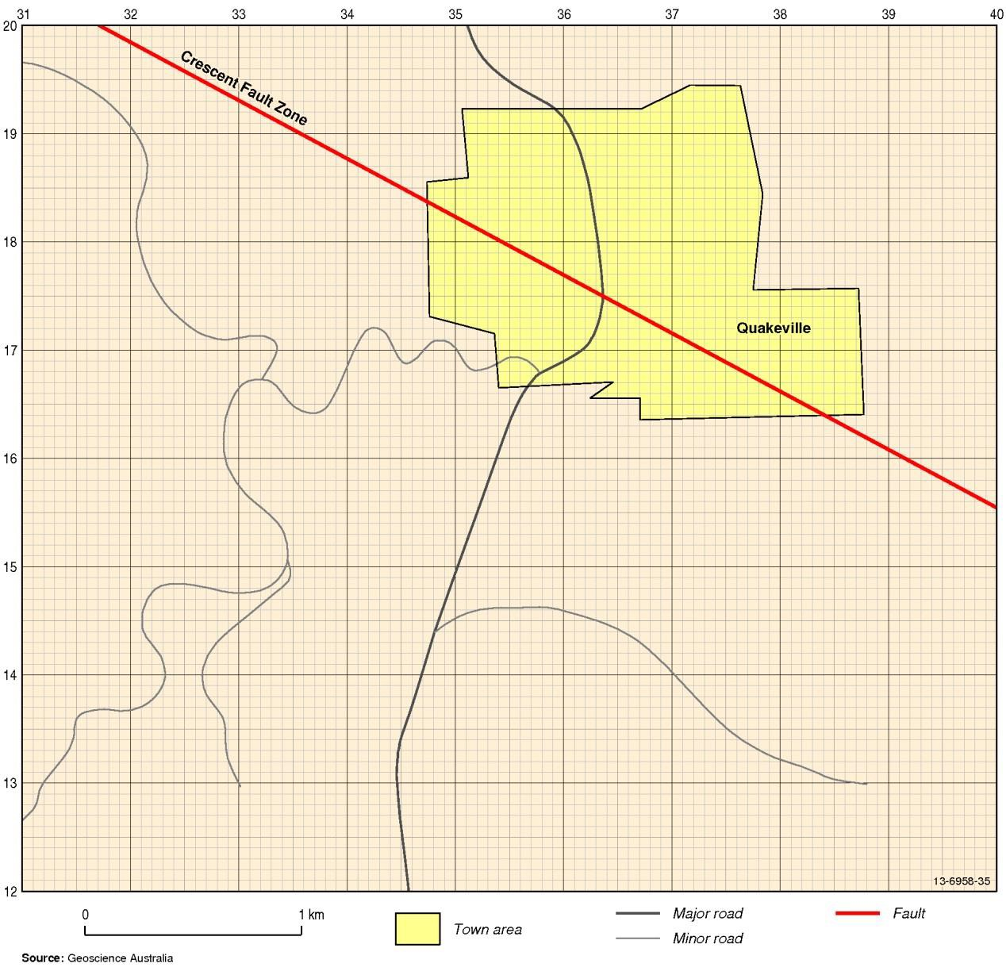

**Modified Mercalli scale of earthquake intensity definitions**

*(adapted from Eiby 1996)*

**Modified Mercalli Scale**

**Description**

0 Micro-earthquakes too small to be felt at all.

1. Not felt by humans, except in especially favourable circumstances, but birds and animals may be disturbed. Reported to be felt mainly from the upper floors of buildings more than ten-storeys high. Dizziness or nausea may be experienced. Branches of trees, doors and other suspended systems may move slowly, but are barely noticeable. Water in ponds, lakes and reservoirs may oscillate (to sway back and forth).
2. Felt by a few people, especially on upper floors. Suspended objects may swing more noticeably.
3. Felt indoors, but not identified as an earthquake by everyone. Vibrations similar to the passing of light traffic. Hanging objects may swing slightly. Standing motorcars may rock slightly.
4. Generally noticed indoors, but not outside. Very light sleepers may awaken. Vibration may be likened to the passing of heavy traffic, or to the jolt of a heavy object falling or striking the building. Walls and frame of building are heard to creak. Dishes, doors and windows rattle. Liquids in open vessels may be slightly disturbed. Standing motorcars may rock, and the shock felt by their occupants.
5. Generally felt outside, and by almost everyone indoors. Most sleepers awaken. A few people frightened. Small unstable objects are displaced or upset. Some dishes and windows broken. Hanging pictures move. Doors and shutters swing. Pendulum clocks stop, start, or change rate.
6. Felt by everyone. People are alarmed and run outside. Difficulty experienced in walking steadily.

Slight damage to poorly built buildings. Some plaster cracks or falls. Some chimney damage. Windows and crockery broken. Objects fall from shelves, and pictures from walls. Heavy furniture

moves. Unstable furniture overturns. Trees and bushes shake.

1. General alarm. Difficulty experienced in standing. Noticed by drivers of motorcars. Trees and bushes strongly shaken. Large bells ring. Poor built buildings cracked and damaged. A few instances of damage to well-built buildings. Loose brickwork and tiles dislodged. Stone walls crack. Weak chimneys break. Domestic rainwater tanks burst. Concrete irrigation ditches damaged. Waves seen on ponds and lakes. Water is made turbid by stirred-up mud. Small slips and caving-in of sand and gravel banks.
2. Alarm may approach panic. Steering of motor cars affected. Poorly built buildings severely damaged.

Well-built buildings sometimes damaged. Chimneys, factory stacks, monuments, towers, and elevated tanks twisted or fall. Panel walls thrown out of frame structures. Some brick veneers damaged. Houses not secured to their foundation may move. Cracks appear on steep slopes and in wet ground. Landslips in roadside cuttings and unsupported excavations. Some tree branches may be broken off.

1. General panic. Well-built buildings heavily damaged, sometimes collapsing completely. Damage to foundations general. Frame houses not secured to the foundations shift off. Brick veneers fall and expose frames. Cracking of the ground. Minor damage to paths and roadways. Sand and mud ejected from ground in some areas. Underground pipes broken. Serious damage to reservoirs.
2. Most buildings destroyed, together with their foundations. Bridges seriously damaged. Dams seriously damaged. Railway lines slightly bent. Cement and asphalt roads badly cracked or thrown into waves. Large landslides occur. Large and spectacular sand and mud fountains. Water from rivers, lakes and canals thrown up on the banks.
3. Few, if any, buildings left standing. Great damage to railway lines. Great damage to underground pipes.
4. Total destruction. Large rock masses displaced. Visible wave-motion of the ground surface reported.

Objects thrown upwards into the air.

**1993 Quakeville earthquake eyewitness comments**

**Grid Ref Comment MM**

355185 I was woken by my bedside clock falling off the table. When I sat up the mirror hanging on the wall at the foot of my bed was moving. *V*

359180 I was making a cup of tea in the kitchen when I heard a crack and a great piece of plaster fell off the wall. Every cup in the house was broken. Later when I went outside I noticed that the chimney was also cracked.

383178 I live on the top floor of a five-storey apartment block. I was awake at the time and could feel a slight sway in the building. The people on the ground floor couldn't feel a thing. *II*

372166 I don't know what all the fuss was about! My wife and I thought it was just a car passing in the street.

360165 I was walking the dog at the time and the whole row of cars parked in our street started to rock.

I could not feel anything myself but the dog freaked out!

325130 No one in our house felt anything, even Grandma and she is a very light sleeper.

*0*

367179 I was frightened. The whole house seemed to sway and the shutters on my bedroom window banged against the house. Later the only damage I could find was a cracked window.

374158 I was resting at home when I felt a slight movement. At the time I thought I was just giddy after a hard day at work. Then I found out that it was an earthquake!

391188 We did not feel a thing. We were both awake at the time watching TV.

379177 I said to my husband that it was strange for a bus to be travelling at that time of day down our street. He then noticed that the light fitting was very slightly swaying.

381198 I was on the roof of our two-storey house fixing the TV aerial at the time. I could feel the house slightly swaying. My wife inside couldn’t feel a thing.

357148 What earthquake? I was writing a letter at the time and didn't feel a thing.

357178 Dad ran around the house waking all us up. There was dust everywhere and big chunks of the ceiling had fallen down. The sofa had moved almost the whole way across the lounge room floor. Mum's favourite light stand had fallen over and was broken. The little bell in the clock was ringing.

370174 I thought a car had hit the side of the house. I ran outside to see if there was any damage but I could find none.

363168 I had just driven home from work and was walking from the car when I heard a creaking sound like our house makes in a strong storm. The night was very still, and other than the sound I could not feel a thing.

387157 My dog started barking and running around the house. She woke us all up but we couldn't work out what was worrying her.

367188 I knew we were having an earthquake. The glasses all rattled in the sideboard and the roller door on the garage make a loud noise like it was being shaken.

362157 The only thing we noticed was the big light fitting which hangs above our stair well was slightly swaying. *II*

339154 I always have trouble sleeping and the swaying of the house really gave me a start. Everyone else in the house slept on as if nothing had happened. There was no noise - it was so very quiet.

323182 Dad was in the barn loft moving hay when he felt the barn sway. We were in the house and couldn’t feel a thing.

|  |  |  |
| --- | --- | --- |
| **Grid Ref** | **Comment** | **MM** |
|  |  |  |
| 315192 | We were playing cards with friends and none of us felt or heard anything. |  |
|  |  |  |
| 353195 | I thought it was a train passing by until I realised that while it felt like a train there was no sound. |  |
|  |  |  |
| 342187 | We could all feel something but we did not know what it was. We were watching TV at the time. |  |
|  |  |  |
| 371195 | The whole house rumbled like a number of cars were passing quickly down the street. We jumped up to look through the windows, but there were no cars in sight. | *III* |
|  |  |  |
| 385143 | The whole house shook and bricks cracked in the fireplace. Most windows in the house cracked and not one glass survived in the cupboards. |  |
|  |  |  |
| 361173 | We had been away overnight but when we got home we found quite a few windows cracked and the good dinner set had most plates broken. The rest of the house seemed undamaged. | *V* |
|  |  |  |
| 380131 | The first we knew about it was that we heard it on the radio. |  |
|  |  |  |
| 345165 | We all felt it and then we spent the rest of the night arguing if it was an earthquake. |  |
|  |  |  |
| 354175 | It was the second quake we have felt since we moved here. Our old grandfather clock started chiming and we had to adjust the time in the morning. We even lost a few ornaments from the mantel piece. |  |

**Earthquakes – Teacher Notes and Student Activities 69**

Earthquake hazard map4

Recommended Age: Senior secondary

When new buildings are designed and built, there are a number of engineering standards that must be met. One of the most important is the Australian Standard AS1170.4 “Structural design actions Part 4: Earthquake actions in Australia”. Geoscience Australia compiles hazard maps, which show the variability of earthquakes in given geographical areas, and their probability of occurring.

The approach to estimating earthquake hazard requires two main factors:

* an earthquake model that describe the likelihood of an earthquake of a given magnitude occurring in a given location; and
* one or more ground motion prediction equation(s) that define the ground-shaking experienced at a given distance from a simulated earthquake of a specific magnitude.

The amount of shaking is expressed as the ‘peak horizontal ground acceleration’. For the sake of convenience, the unit is ‘g’, the acceleration due to gravity with S.I. units of m/s2. In other words, the fastest measured *change in speed* for a particle at ground level that is moving horizontally because of an earthquake. Realistic numbers fall between 0 and 14% g.

Hazard maps don’t simply show the peak horizontal ground acceleration for a given place. Seismologists construct contour lines which show areas that have a 10 per cent probability that the horizontal ground acceleration (or shaking of the ground) will exceed the *peak horizontal ground acceleration* in a 500 year period.

For example, areas within the 0.12 contour have a 10% probability that the strength of shaking due to an earthquake is greater than 0.12 times the acceleration due to gravity. This is equivalent to saying that, over a 500 year period, a building or other structure within that area is likely to experience an earthquake which causes the ground to shake by at least 0.12g.

Damage will start to occur at the 0.05 level and increase as the number increases.

4 For more information, visi[t http://earthquake.usgs.gov/hazards/about/basics.php.](http://earthquake.usgs.gov/hazards/about/basics.php)

**Seismic hazard map of Australia**

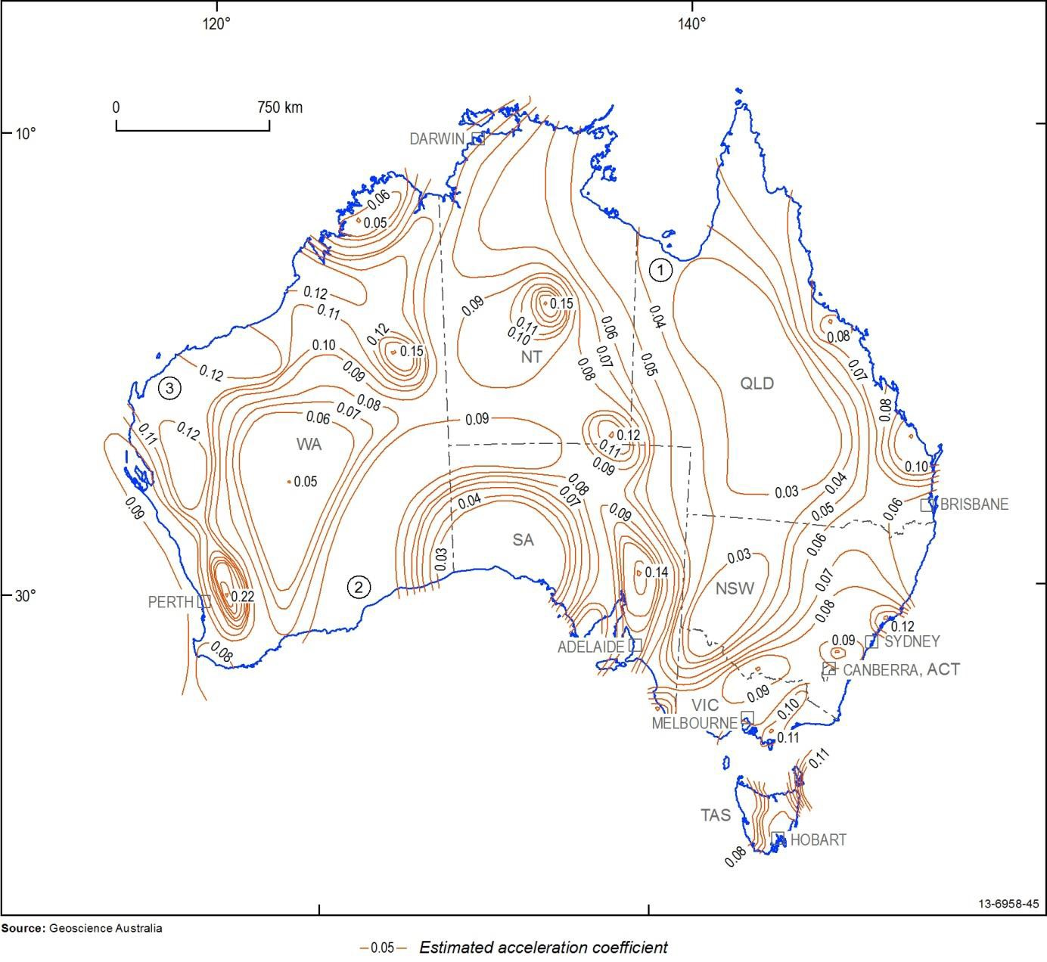

1. Locate where you live. What is the value for your area?
2. What is the highest value on the map and in what State or Territory does this occur?
3. Take three coloured pencils, red, orange and yellow would be best, and colour the map between the contours using the key below:

|  |  |
| --- | --- |
| **Colour** | **Where** |
|  |  |
| Yellow | Between 0.09 and 0.11 |
|  |  |
| Orange | Between 0.11 and 0.13 |
|  |  |
| Red | Between 0.13 and greater |

Your map now highlights those areas of high risk of being damaged by an earthquake in the next 500 years.

1. Which capital city in Australia would be the most prone to earthquake damage?
2. Imagine you are a seismologist and have been asked for your advice on which of the locations marked 1, 2, 3 on the map would be the best for a new city in which all the buildings were to be skyscrapers. Which would you suggest and why?

Answers

Find Detritus!

##### Tracy walked home from school one day and found a message pinned to her front door. The message said:

*"Tracy, Your dog Detritus has escaped your back yard and has run away. I saw it go at 3pm but I could not catch it. By the time you read this it would be 2 kilometres away! Sorry I can’t help you find Detritus as I have a piano lesson. Rod"*

##### Describe the shape of the area where Tracy needs to look to find her dog:

###### Circle

##### Using the map, where will Tracy find her escaped four-legged fugitive?

###### Corner of Bone Lane and Newham Drive

**Map of Quakeville**

##### When an earthquake occurs, seismographs in many locations detect the shaking of the earth. From the data they record, seismologists can calculate how far from each seismometer the earthquake took place. They can then use the method that you have just used to find Detritus to find the epicentre of the earthquake, even if it is underwater!

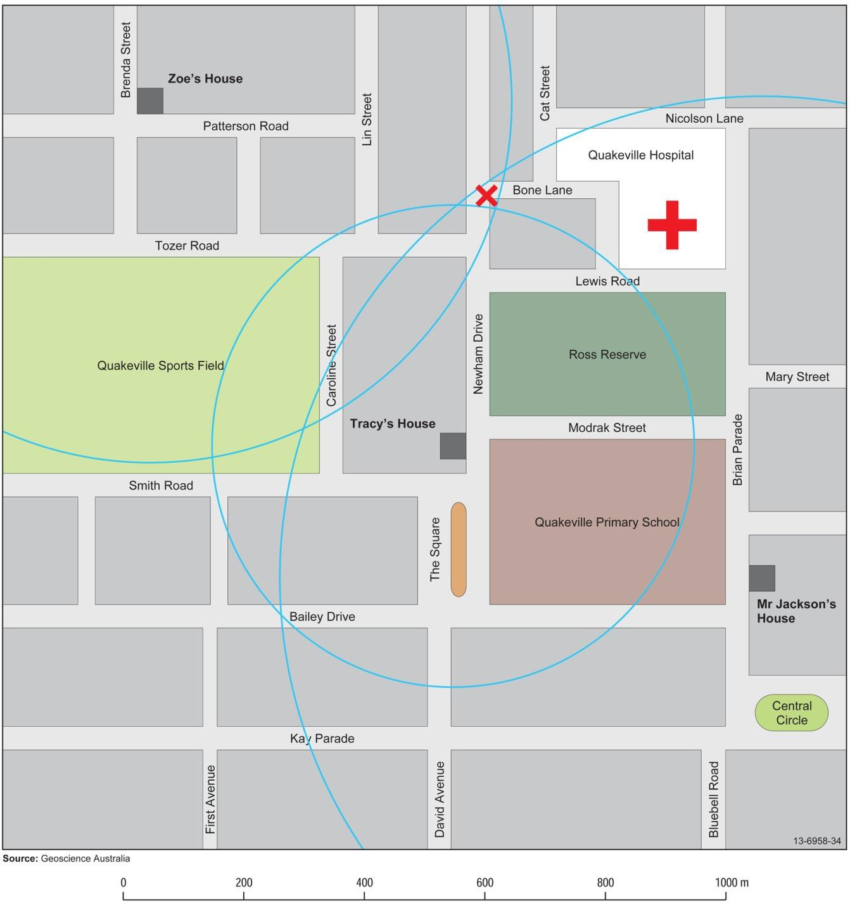

Epicentre hunt

* 1. What are the differences in arrival time of the P and S waves for each Station?

|  |  |  |
| --- | --- | --- |
| **Station** | **Difference in arrival time between P and S (sec)** | **Distance from epicentre (km)** |
| **a.** Quakeville Station | *6.0 seconds* | *53 km* |
| **b.** Pearsons Crossing Station | *6.4 seconds* | *58 km* |
| **c.** Well Station | *4.2 seconds* | *38 km* |

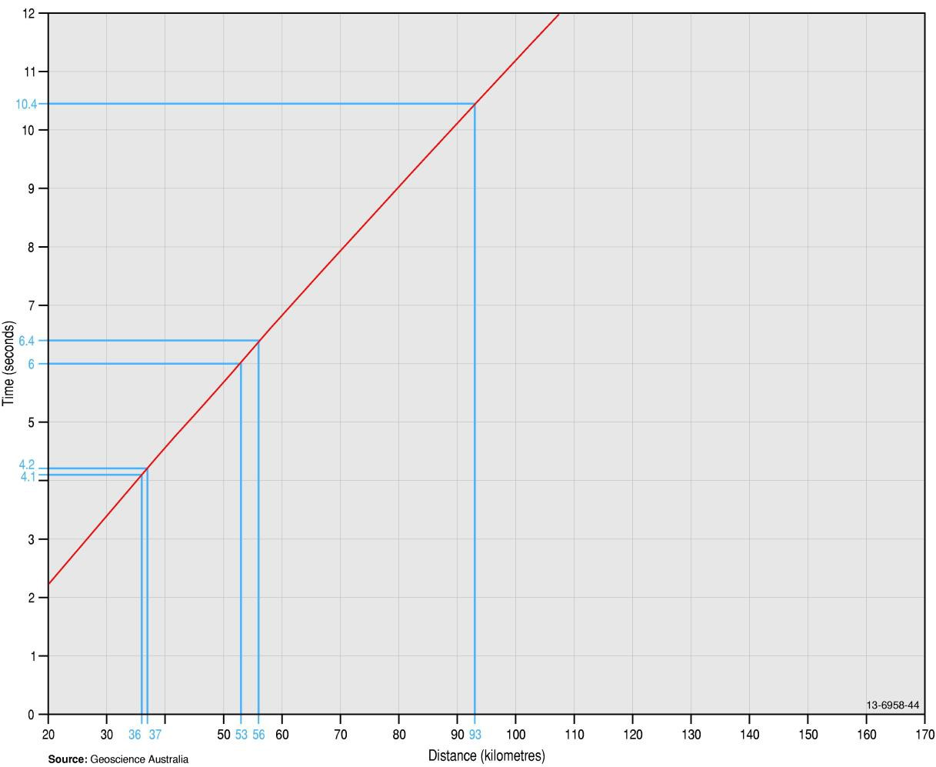

1. Will any township or homesteads be affected if a more intense earthquake follows this tremor?

###### Two homesteads – one 15 kilometres, one 22 kilometres away.

1. What action could you take to warn people who may be affected without raising the alarm of other non-effected residents?

###### As there are only two homesteads, call them and advise them what action to take in the event of an earthquake.

|  |  |  |
| --- | --- | --- |
| **Station** | **Difference in arrival time between P and S (sec)** | **Distance from epicentre (km)** |
| **d.** Upper Valley Station | *10.4 seconds* | *94 km* |
| **e.** Bucktown Station | *4.1 seconds* | *37 km* |

Upper Valley Station

13-6958-38

0 10 20 30 40 50 60 70 80 90 100km

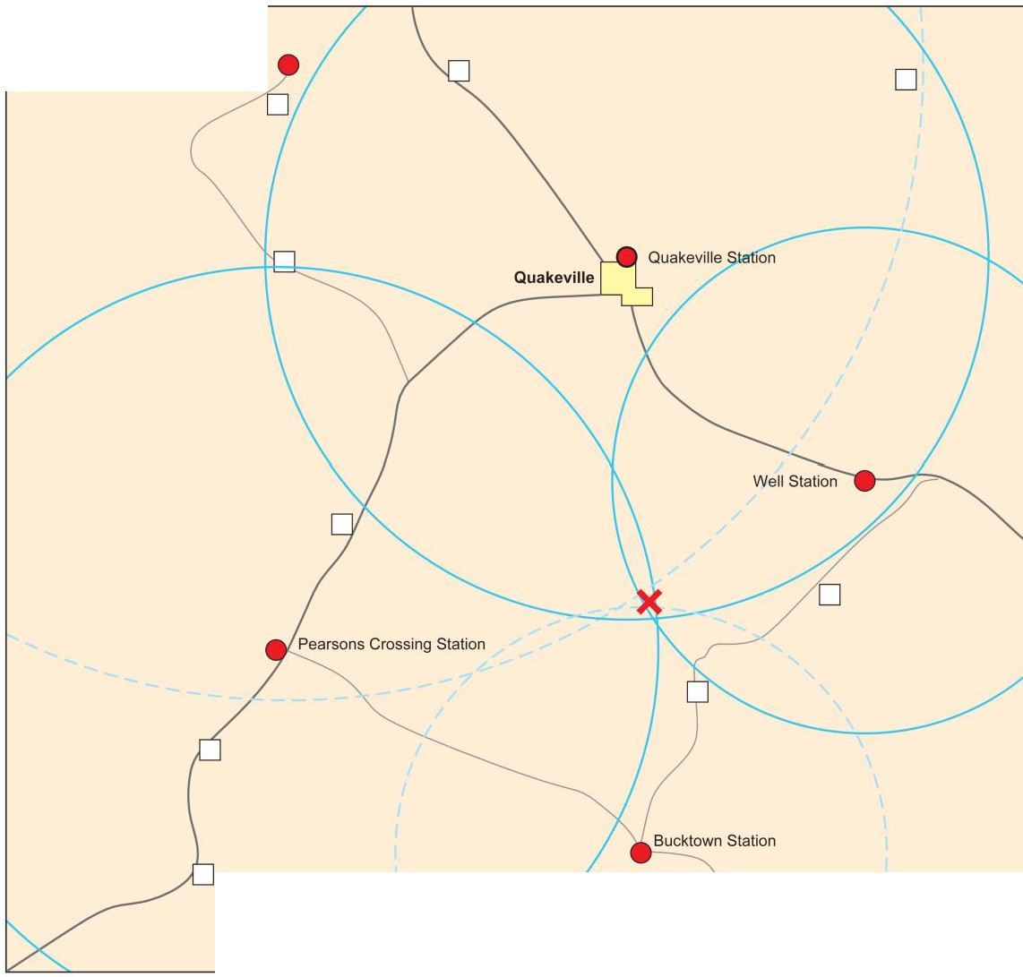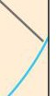

D*Townarea*

**Source:Geoscience Australia**

-- *Maj or road* -- *Minor road*

* *Seismic station* 0 *Homestead*

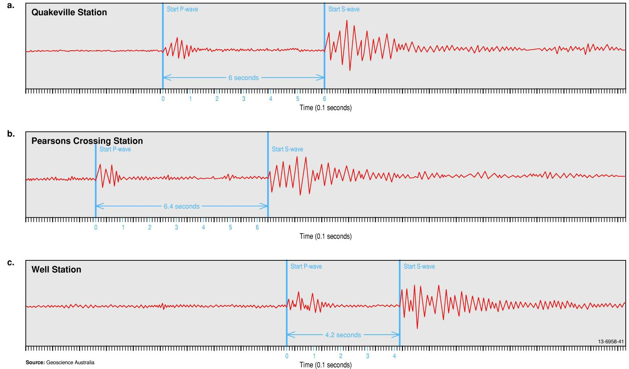

**Earthquakes – Teacher Notes and Student Activities 79**

d.



Upper Valley Station

Start P-wave

Star! S-wave

2 3 4

Time (0.1 seconds)

8 10

e. Bucktown Station Star" P-wave StartS-wave

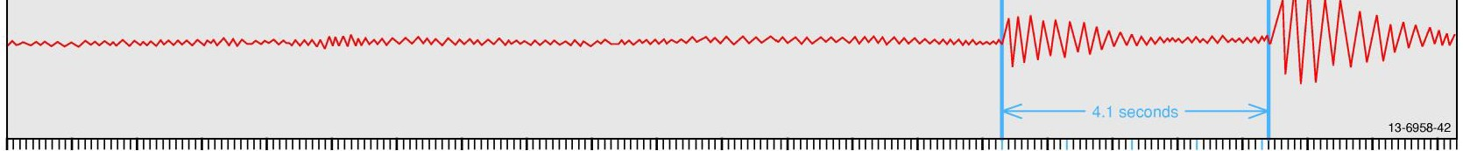

2 4

Source: Geoscience Australia Time (0.1 seconds)

Quakeville earthquake

**NEWS FLASH**

* 1. What was the greatest intensity (MM number) for this earthquake: *VI*

**Map of Quakeville region**

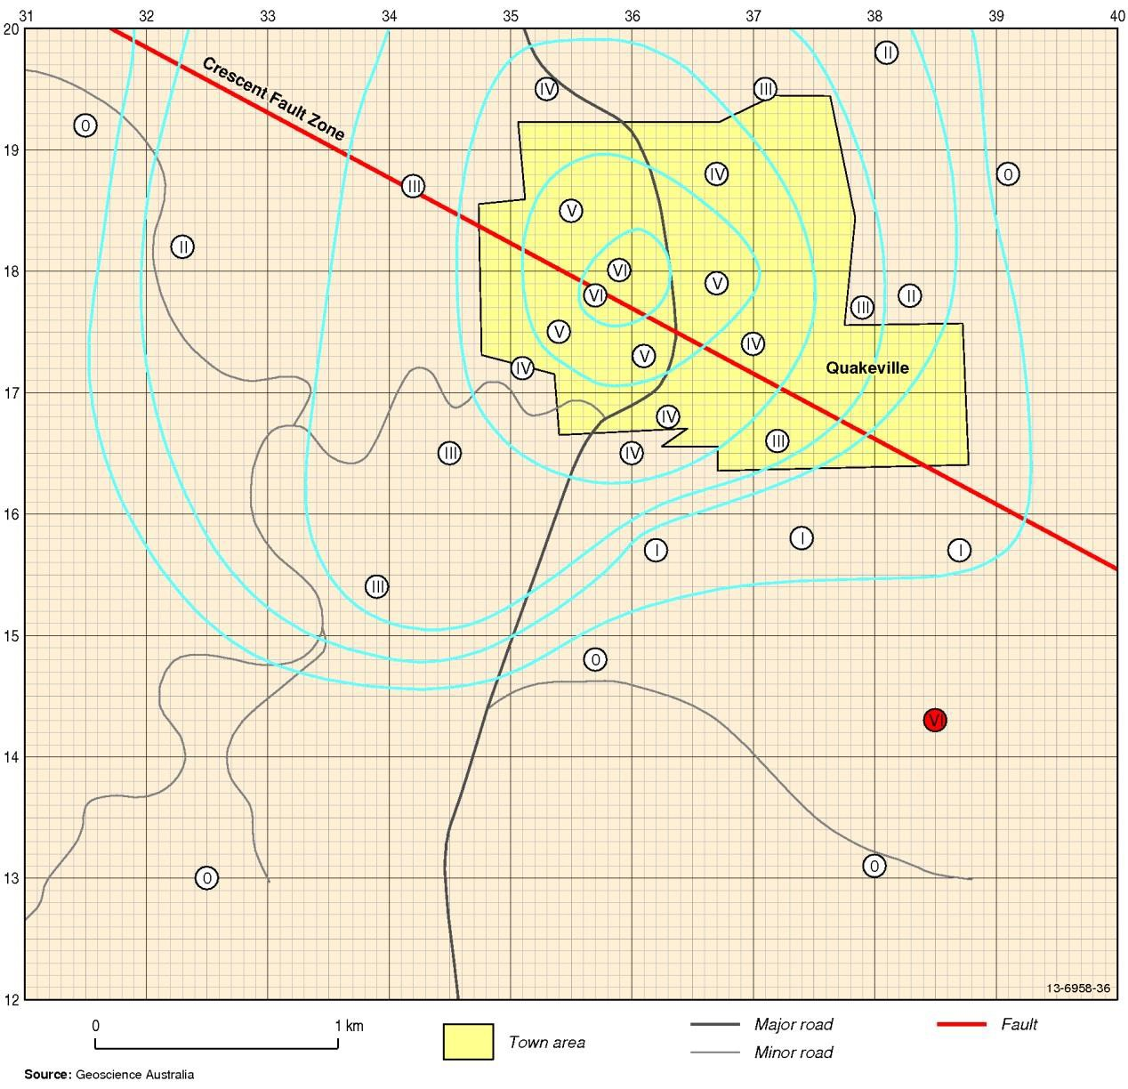

**1993 Quakeville earthquake eyewitness comments**

**Grid Ref Comment MM**

355185 I was woken by my bedside clock falling off the table. When I sat up, the mirror hanging on the wall at the foot of my bed was moving.

359180 I was making a cup of tea in the kitchen when I heard a crack and a great piece of plaster fell off the wall. Every cup in the house was broken. Later when I went outside I noticed that the chimney was also cracked.

383178 I live on the top floor of a five-storey apartment block. I was awake at the time and could feel a slight sway in the building. The people on the ground floor couldn't feel a thing.

372166 I don't know what all the fuss was about! My wife and I thought it was just a car passing in the street.

360165 I was walking the dog at the time and the whole row of cars parked in our street started to rock. I could not feel anything myself but the dog freaked out!

#### V VI

#### II

#### III IV

325130 No one in our house felt anything, even Grandma and she is a very light sleeper. *O*

367179 A was frightened. The whole house seemed to sway and the shutters on my *V*

bedroom window banged against the house. Later the only damage I could find

was a cracked window.

374158 I was resting at home when I felt a slight movement. At the time I thought I was *I*

just giddy after a hard day at work. Then I found out that it was an earthquake!

391188 We did not feel a thing. We were both awake at the time watching TV. *O*

379177 I said to my husband that it was strange for a bus to be travelling at that time of day down our street. He then noticed that the light fitting was very slightly swaying.

381198 I was on the roof of our two-storey house fixing the TV aerial at the time. I could feel the house slightly swaying. My wife inside couldn’t feel a thing.

*III*

#### II

357148 What earthquake? I was writing a letter at the time and didn't feel a thing. *O*

357178 Dad ran around the house waking all us up. There was dust everywhere and big *VI*

chunks of the ceiling had fallen down. The sofa had moved almost the whole

way across the lounge room floor. Mum's favourite light stand had fallen over and was broken. The little bell in the clock was ringing.

370174 I thought a car had hit the side of the house. I ran outside to see if there was any *IV*

damage but I could find none.

363168 I had just driven home from work and was walking from the car when I heard a *IV*

creaking sound like our house makes in a strong storm. The night was very still,

and other than the sound I could not feel a thing.

387157 My dog started barking and running around the house. She woke us all up but *I*

we couldn't workout what was worrying her.

367188 I knew we were having an earthquake. The glasses all rattled in the sideboard *IV*

and the roller door on the garage make a loud noise like it was being shaken.

362157 The only thing we noticed was the big light fitting which hangs above our stair *II*

well was slightly swaying.

|  |  |  |
| --- | --- | --- |
| **Grid Ref** | **Comment** | **MM** |
|  |  |  |
| 339154 | I always have trouble sleeping and the swaying of the house really gave me a start. Everyone else in the house slept on as if nothing had happened. There was no noise - it was so very quiet. | *II* |
| 323182 | Dad was in the barn loft moving hay when he felt the barn sway. We were in the house and couldn’t feel a thing. | *II* |
| 315192 | We were playing cards with friends and none of us felt or heard anything. | *O* |
| 353195 | I thought it was a train passing by until I realised that while it felt like a train there was no sound. | *III* |
| 342187 | We could all feel something but we did not know what it was. We were watching TV at the time. | *III* |
| 371195 | The whole hose rumbled like a number of cars were passing quickly down the street. We jumped up to look through the windows, but there were no cars in sight. | *III* |
|  |  |  |
| 385143 | The whole house shook and bricks cracked in the fireplace. Most windows in the house cracked and not one glass survived in the cupboards. | *VI* |
| 361173 | We had been away overnight but when we got home we found quite a few windows cracked and the good dinner set had most plates broken. The rest of the house seemed undamaged. | *V* |
|  |  |  |
| 380131 | The first we knew about it was that we heard it on the radio. | *O* |
| 345165 | We all felt it and then we spent the rest of the night arguing if it was an earthquake. | *III* |
| 354175 | It was the second quake we have felt since we moved here. Our old grandfather clock started chiming and we had to adjust the time in the morning. We even lost a few ornaments from the mantel piece. | *V* |

**Earthquakes – Teacher Notes and Student Activities 83**

Earthquake hazard map

* + 1. Locate where you live. What is the value for your area?

###### This answer varies depending on where you live.

* + 1. What is the highest value on the map and in what State or Territory does this occur?

###### 0.22 Western Australia

* + 1. Which capital city in Australia would be the most prone to earthquake damage?

###### Adelaide

* + 1. Imagine you are a seismologist and have been asked for your advice on which of the locations marked 1, 2, 3 on the map would be the best for a new city in which all the buildings were to be skyscrapers. Which would you suggest and why?

###### Number 1 because it has the lowest seismic hazard risk number 0.035.

**84 Earthquakes – Teacher Notes and Student Activities**